|  |  |  |  |
| --- | --- | --- | --- |
| logo ngan.png | | **MINISTRY OF EDUCATION AND TRAINING** | |
| **FPT UNIVERSITY** | |
| **CAPSTONE PROJECT DOCUMENT** | |
| **BUILDING A WEBSITE SUPPORT THE ACTIVITIES “TIẾP SỨC MÙA THI” CAMPAIGN**  **Project Report #3 – System Requirements Specifications** | |
|  | |
| |  |  | | --- | --- | | **Group 22** | | | **Group Members** | |  |  | | --- | --- | | SE60769 | Nguyen Duy Khoa | | SE60687 | Le Nguyen Huu Tri | | 60358 | Nguyen Dinh Tuan | | 60325 | Tran Nguyen Kim Vinh | | 60339 | Nguyen Vinh Hien | | | **Supervisor** | Nguyen Trong Tai | | **Ext Supervisor** | N/A | | **Capstone Project Code** | TSMT | | |
| - Ho Chi Minh City, February 2014 – | |

Table of Contents

3. SOFTWARE REQUIREMENT SPECIFICATION 3

3.1. User Requirement Specification 3

3.1.1. Guest Requirements 3

3.1.2. Authorized User Requirements 3

3.1.3. Candidate Requirements 3

3.1.4. Charity Requirements 3

3.1.5. Volunteer Requirements 3

3.1.6. Sponsor Requirements 3

3.1.7. Admin Requirements 3

3.2. System Requirement Specification (Specific Requirements) 3

3.2.1. External Interface Requirements 3

3.2.2. Main Flow Overviews 4

3.2.3. Functional Requirements 4

3.2.4. Non-functional Requirements 28

3.3. Entity Relationship Diagram or Data Structure 28

3.3.1. Entity Relationship Diagram 28

3.3.2. Entity Detail 28

# SOFTWARE REQUIREMENT SPECIFICATION

## User Requirement Specification

The system must satisfy the following defined requirements:

### Guest Requirements

A guest is an unauthenticated user of the website. He or she can:

* Log in with his/her authorized account.
* Register a new account.
* View articles about lodges, charities, examination…
* Search charities’ information
* Search information of lodges

### Authorized User Requirements

### Candidate Requirements

### Charity Requirements

### Volunteer Requirements

### Sponsor Requirements

### Admin Requirements

## System Requirement Specification (Specific Requirements)

### External Interface Requirements

#### User Interfaces

#### Hardware Interfaces

#### System Interfaces

#### Communication Protocol

### Main Flow Overviews

### Functional Requirements

#### Overall Use case diagram

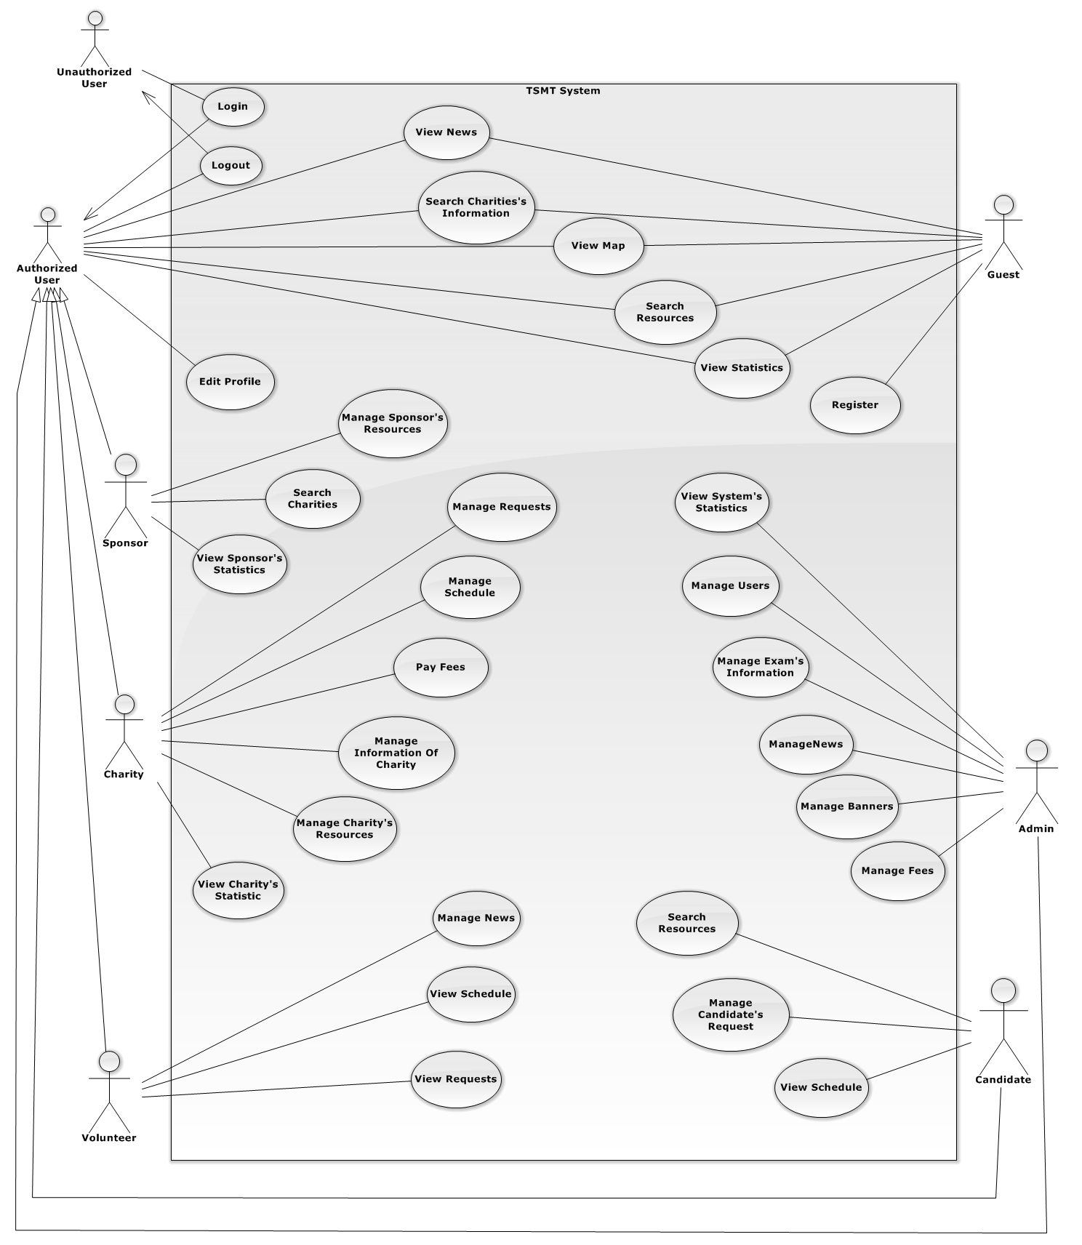

#### Unauthorized User Login

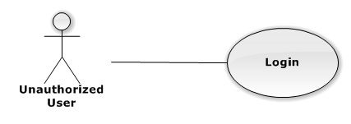

|  |  |  |  |  |
| --- | --- | --- | --- | --- |
| **USE CASE-UC001 SPECIFICATION** | | | | |
| **Use-case No.** | UC001 | **Use-case Version** | | 1.0 |
| **Use-case Name** | Login | | | |
| **Author** |  | | | |
| **Date** |  | **Priority** | High | |
| **Actor:**  **Summary:**  **Goal:**  **Triggers:**  **Preconditions:**  **Post Conditions:**  *On success:*  *On failure:*  **Main Success Scenario:**   |  |  |  | | --- | --- | --- | | **Step** | **User Action** | **System Response** | | 1. |  |  | | 2. |  |  |   **Alternative Scenario:**   |  |  |  |  | | --- | --- | --- | --- | | **No** | **Step** | **User Action** | **System Response** | | 1. | 1. |  |  | |  | 2. |  |  | | 2. | 1. |  |  | |  | 2. |  |  |   **Exceptions:**   |  |  |  | | --- | --- | --- | | **No** | **User Action** | **System Response** | | 1. |  |  | | 2. |  |  | | 3. |  |  | | 4. |  |  | | 5. |  |  |   **Relationships:**  “Manage prices” abstract use case  **Business Rules:**   |  |  | | --- | --- | | **No** | **Business Rule Description** | | 1. |  | | 2. |  | | 3. |  | | | | | |

#### Authorized User Edit Profile

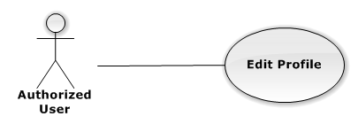

|  |  |  |  |  |
| --- | --- | --- | --- | --- |
| **USE CASE-UC002 SPECIFICATION** | | | | |
| **Use-case No.** | UC002 | **Use-case Version** | | 1.0 |
| **Use-case Name** | Edit Profile | | | |
| **Author** | Nguyen Dinh Tuan | | | |
| **Date** | 15/02/2014 | **Priority** | Normal | |
| **Actor:**  Authorized User  **Summary:**  Authorized user can edit the information need, to supplement incomplete information at registration step.  **Goal:**  It helps Authorized User to edit profile  **Triggers:**  Authorized User wants to edit profile.  Authorized User click “Edit Profile” on the individual menu which has “Edit” status  **Preconditions:**  The page is fully loaded  User log in with “Authorized User” role.  Stay at Homepage.  **Post Conditions:**  *On success:* Message box will be shown “You have just updated your personal information successfully!” and go to Homepage  *On failure:* System display error message. Content of error message will be specified in Exception section.  **Main Success Scenario:**   |  |  |  | | --- | --- | --- | | **Step** | **User Action** | **System Response** | | 1. | Click “Edit Profile” tab to view basic information |  | | 2. |  | Display a table with profile information of authorized User   * Name * Birthday * Gender * Email * Address * Phone * Password | | 3 | Click any line to edit information |  | | 4 | Click “Update” to Update information |  | | 5 |  | Show confirmation message: “Are You sure to save?” with “OK” button and “Cancel” button. [See Alternative 1] | | 6 | Click “OK” button to cancel update. |  | | 7 |  | Close info message box, update new information and back to Home page |   **Alternative Scenario:**   |  |  |  |  | | --- | --- | --- | --- | | **No** | **Step** | **User Action** | **System Response** | | 1. | 1. | Click “Cancel” button. |  | |  | 2. |  | Close info message box and back to Home page |   **Exceptions:**  N/A  **Relationships:**  Login  **Business Rules:**  N/A | | | | |

#### Authorized User Logout

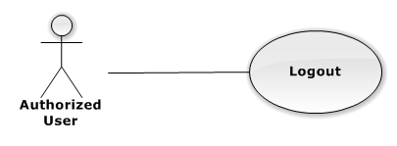

|  |  |  |  |  |
| --- | --- | --- | --- | --- |
| **USE CASE-UC003 SPECIFICATION** | | | | |
| **Use-case No.** | UC003 | **Use-case Version** | | 1.0 |
| **Use-case Name** | Logout | | | |
| **Author** |  | | | |
| **Date** |  | **Priority** | High | |
| **Actor:**  **Summary:**  **Goal:**  **Triggers:**  **Preconditions:**  **Post Conditions:**  *On success:*  *On failure:*  **Main Success Scenario:**   |  |  |  | | --- | --- | --- | | **Step** | **User Action** | **System Response** | | 1. |  |  | | 2. |  |  |   **Alternative Scenario:**   |  |  |  |  | | --- | --- | --- | --- | | **No** | **Step** | **User Action** | **System Response** | | 1. | 1. |  |  | |  | 2. |  |  | | 2. | 1. |  |  | |  | 2. |  |  |   **Exceptions:**   |  |  |  | | --- | --- | --- | | **No** | **User Action** | **System Response** | | 1. |  |  | | 2. |  |  | | 3. |  |  | | 4. |  |  | | 5. |  |  |   **Relationships:**  “Manage prices” abstract use case  **Business Rules:**   |  |  | | --- | --- | | **No** | **Business Rule Description** | | 1. |  | | 2. |  | | 3. |  | | | | | |

#### GuestRegister

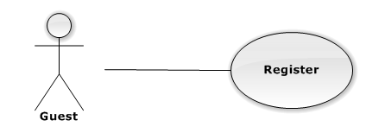

|  |  |  |  |  |
| --- | --- | --- | --- | --- |
| **USE CASE-UC004 SPECIFICATION** | | | | |
| **Use-case No.** | UC004 | **Use-case Version** | | 1.0 |
| **Use-case Name** | Register | | | |
| **Author** |  | | | |
| **Date** |  | **Priority** | High | |
| **Actor:**  **Summary:**  **Goal:**  **Triggers:**  **Preconditions:**  **Post Conditions:**  *On success:*  *On failure:*  **Main Success Scenario:**   |  |  |  | | --- | --- | --- | | **Step** | **User Action** | **System Response** | | 1. |  |  | | 2. |  |  |   **Alternative Scenario:**   |  |  |  |  | | --- | --- | --- | --- | | **No** | **Step** | **User Action** | **System Response** | | 1. | 1. |  |  | |  | 2. |  |  | | 2. | 1. |  |  | |  | 2. |  |  |   **Exceptions:**   |  |  |  | | --- | --- | --- | | **No** | **User Action** | **System Response** | | 1. |  |  | | 2. |  |  | | 3. |  |  | | 4. |  |  | | 5. |  |  |   **Relationships:**  “Manage prices” abstract use case  **Business Rules:**   |  |  | | --- | --- | | **No** | **Business Rule Description** | | 1. |  | | 2. |  | | 3. |  | | | | | |

#### Guest, Authorized UserSearch Charity’s Information

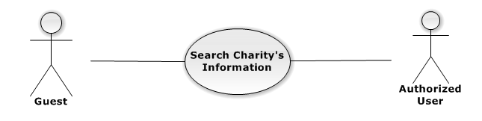

|  |  |  |  |  |
| --- | --- | --- | --- | --- |
| **USE CASE-UC005 SPECIFICATION** | | | | |
| **Use-case No.** | UC005 | **Use-case Version** | | 1.0 |
| **Use-case Name** | Search Charity’s Information | | | |
| **Author** | Nguyen Vinh Hien | | | |
| **Date** | 13/02/2014 | **Priority** | High | |
| **Actor:**  Guest, Authorized User  **Summary:**  Guest, Authorized User can search charity’s information of the system  **Goal:**  Help guest and authorized user to search charity’s information of the system easier.  **Triggers:**  Authorized User want to see the charity’s information that exist in the system  (guest inputs key words on textbox then clicks “Tìm kiếm” icon at the right corner of frame to search follow key words inputted)  **Preconditions:**  Login successful with any role  The page is fully loaded  **Post Conditions:**  *On success:* Charity’s information of the system are displayed as thumbnails  Charity’s information are displayed correctly corresponding to optional inputted  *On failure:* An error message is displayed. The content of the error message will be specified in the Exception Scenario section based on the type of failure.  **Main Success Scenario:**   |  |  |  | | --- | --- | --- | | **Step** | **User Action** | **System Response** | | 1. | Guest, Authorized User input key words into textbox  [See Alternative1] [See Alternative2] |  | | 2. | Guest, Authorized User click "Tìm kiếm" icon |  | | 3 |  | Display charity’s information matches key words or options that user selected in step 1 in thumbnails icon. |   **Alternative Scenario:**   |  |  |  |  | | --- | --- | --- | --- | | **No** | **Step** | **User Action** | **System Response** | | 1. | 1. | Guest, Authorized User choose district check box |  | |  | 2. |  | List charity in the district matches with check box that user selected | | 2. | 1. | Authorized check on exam check box |  | |  | 2. |  | Filter charity support for the exam season that user selected. |   **Exceptions:**   |  |  |  | | --- | --- | --- | | **No** | **User Action** | **System Response** | | 1. | N/A | N/A |   **Relationships:**  N/A  **Business Rules:**   |  |  | | --- | --- | | **No** | **Business Rule Description** | | 1. | Authorized User can search charity’s information with many options selected  Inputted key words have to match at least one charity or meaning words | | | | | |

#### Guest, Authorized UserSearch Resources

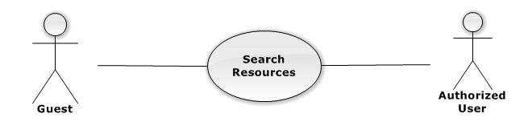

|  |  |  |  |  |
| --- | --- | --- | --- | --- |
| **USE CASE-UC006 SPECIFICATION** | | | | |
| **Use-case No.** | UC006 | **Use-case Version** | | 1.0 |
| **Use-case Name** | Search Resources | | | |
| **Author** | Nguyen Vinh Hien | | | |
| **Date** | 13/02/2014 | **Priority** | High | |
| **Actor:**  Guest, Authorized User  **Summary:**  Guest, Authorized User can search resources (lodges, cars) of the system  **Goal:**  Help  **Triggers:**  **Preconditions:**  **Post Conditions:**  *On success:*  *On failure:*  **Main Success Scenario:**   |  |  |  | | --- | --- | --- | | **Step** | **User Action** | **System Response** | | 1. |  |  | | 2. |  |  |   **Alternative Scenario:**   |  |  |  |  | | --- | --- | --- | --- | | **No** | **Step** | **User Action** | **System Response** | | 1. | 1. |  |  | |  | 2. |  |  | | 2. | 1. |  |  | |  | 2. |  |  |   **Exceptions:**   |  |  |  | | --- | --- | --- | | **No** | **User Action** | **System Response** | | 1. |  |  | | 2. |  |  | | 3. |  |  | | 4. |  |  | | 5. |  |  |   **Relationships:**  “Manage prices” abstract use case  **Business Rules:**   |  |  | | --- | --- | | **No** | **Business Rule Description** | | 1. |  | | 2. |  | | 3. |  | | | | | |

#### Guest, Authorized UserView Map

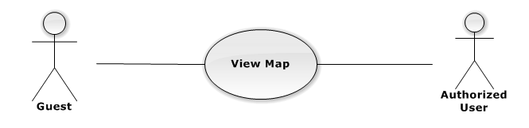

|  |  |  |  |  |
| --- | --- | --- | --- | --- |
| **USE CASE-UC007 SPECIFICATION** | | | | |
| **Use-case No.** | UC007 | **Use-case Version** | | 1.0 |
| **Use-case Name** | View Map | | | |
| **Author** |  | | | |
| **Date** |  | **Priority** | High | |
| **Actor:**  **Summary:**  **Goal:**  **Triggers:**  **Preconditions:**  **Post Conditions:**  *On success:*  *On failure:*  **Main Success Scenario:**   |  |  |  | | --- | --- | --- | | **Step** | **User Action** | **System Response** | | 1. |  |  | | 2. |  |  |   **Alternative Scenario:**   |  |  |  |  | | --- | --- | --- | --- | | **No** | **Step** | **User Action** | **System Response** | | 1. | 1. |  |  | |  | 2. |  |  | | 2. | 1. |  |  | |  | 2. |  |  |   **Exceptions:**   |  |  |  | | --- | --- | --- | | **No** | **User Action** | **System Response** | | 1. |  |  | | 2. |  |  | | 3. |  |  | | 4. |  |  | | 5. |  |  |   **Relationships:**  “Manage prices” abstract use case  **Business Rules:**   |  |  | | --- | --- | | **No** | **Business Rule Description** | | 1. |  | | 2. |  | | 3. |  | | | | | |

#### Guest, Authorized UserView News

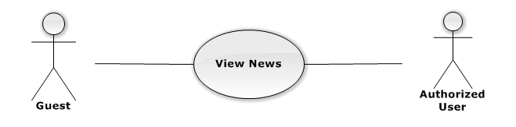

|  |  |  |  |  |
| --- | --- | --- | --- | --- |
| **USE CASE-UC008 SPECIFICATION** | | | | |
| **Use-case No.** | UC008 | **Use-case Version** | | 1.0 |
| **Use-case Name** | View News | | | |
| **Author** |  | | | |
| **Date** |  | **Priority** | High | |
| **Actor:**  **Summary:**  **Goal:**  **Triggers:**  **Preconditions:**  **Post Conditions:**  *On success:*  *On failure:*  **Main Success Scenario:**   |  |  |  | | --- | --- | --- | | **Step** | **User Action** | **System Response** | | 1. |  |  | | 2. |  |  |   **Alternative Scenario:**   |  |  |  |  | | --- | --- | --- | --- | | **No** | **Step** | **User Action** | **System Response** | | 1. | 1. |  |  | |  | 2. |  |  | | 2. | 1. |  |  | |  | 2. |  |  |   **Exceptions:**   |  |  |  | | --- | --- | --- | | **No** | **User Action** | **System Response** | | 1. |  |  | | 2. |  |  | | 3. |  |  | | 4. |  |  | | 5. |  |  |   **Relationships:**  “Manage prices” abstract use case  **Business Rules:**   |  |  | | --- | --- | | **No** | **Business Rule Description** | | 1. |  | | 2. |  | | 3. |  | | | | | |

#### Guest, Authorized UserView Statistics

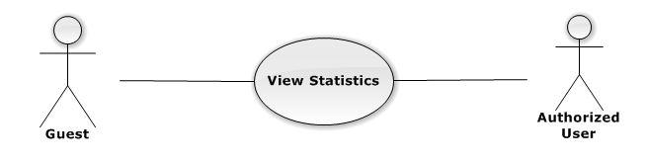

|  |  |  |  |  |
| --- | --- | --- | --- | --- |
| **USE CASE-UC009 SPECIFICATION** | | | | |
| **Use-case No.** | UC009 | **Use-case Version** | | 1.0 |
| **Use-case Name** | View Statistics | | | |
| **Author** |  | | | |
| **Date** |  | **Priority** | High | |
| **Actor:**  **Summary:**  **Goal:**  **Triggers:**  **Preconditions:**  **Post Conditions:**  *On success:*  *On failure:*  **Main Success Scenario:**   |  |  |  | | --- | --- | --- | | **Step** | **User Action** | **System Response** | | 1. |  |  | | 2. |  |  |   **Alternative Scenario:**   |  |  |  |  | | --- | --- | --- | --- | | **No** | **Step** | **User Action** | **System Response** | | 1. | 1. |  |  | |  | 2. |  |  | | 2. | 1. |  |  | |  | 2. |  |  |   **Exceptions:**   |  |  |  | | --- | --- | --- | | **No** | **User Action** | **System Response** | | 1. |  |  | | 2. |  |  | | 3. |  |  | | 4. |  |  | | 5. |  |  |   **Relationships:**  “Manage prices” abstract use case  **Business Rules:**   |  |  | | --- | --- | | **No** | **Business Rule Description** | | 1. |  | | 2. |  | | 3. |  | | | | | |

#### CharityManage Charity’s Information

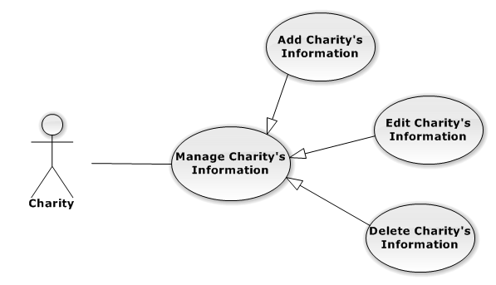

##### **CharityManage Charity’s Information - Add Charity’s Information**

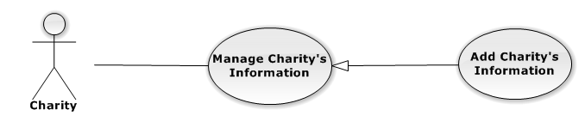

|  |  |  |  |  |
| --- | --- | --- | --- | --- |
| **USE CASE-UC010 SPECIFICATION** | | | | |
| **Use-case No.** | UC010 | **Use-case Version** | | 1.0 |
| **Use-case Name** | Add Charity’s Information | | | |
| **Author** |  | | | |
| **Date** |  | **Priority** | High | |
| **Actor:**  **Summary:**  **Goal:**  **Triggers:**  **Preconditions:**  **Post Conditions:**  *On success:*  *On failure:*  **Main Success Scenario:**   |  |  |  | | --- | --- | --- | | **Step** | **User Action** | **System Response** | | 1. |  |  | | 2. |  |  |   **Alternative Scenario:**   |  |  |  |  | | --- | --- | --- | --- | | **No** | **Step** | **User Action** | **System Response** | | 1. | 1. |  |  | |  | 2. |  |  | | 2. | 1. |  |  | |  | 2. |  |  |   **Exceptions:**   |  |  |  | | --- | --- | --- | | **No** | **User Action** | **System Response** | | 1. |  |  | | 2. |  |  | | 3. |  |  | | 4. |  |  | | 5. |  |  |   **Relationships:**  “Manage prices” abstract use case  **Business Rules:**   |  |  | | --- | --- | | **No** | **Business Rule Description** | | 1. |  | | 2. |  | | 3. |  | | | | | |

##### **CharityManage Charity’s Information - Edit Charity’s Information**

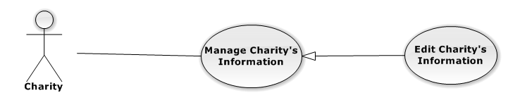

|  |  |  |  |  |
| --- | --- | --- | --- | --- |
| **USE CASE-UC011 SPECIFICATION** | | | | |
| **Use-case No.** | UC011 | **Use-case Version** | | 1.0 |
| **Use-case Name** | Edit Charity’s Information | | | |
| **Author** | Nguyen Dinh Tuan | | | |
| **Date** | 15/02/2014 | **Priority** | Normal | |
| **Actor:**  Charity  **Summary:**  Charity can edit the information nee  **Goal:**  **Triggers:**  **Preconditions:**  **Post Conditions:**  *On success:*  *On failure:*  **Main Success Scenario:**   |  |  |  | | --- | --- | --- | | **Step** | **User Action** | **System Response** | | 1. |  |  | | 2. |  |  |   **Alternative Scenario:**   |  |  |  |  | | --- | --- | --- | --- | | **No** | **Step** | **User Action** | **System Response** | | 1. | 1. |  |  | |  | 2. |  |  | | 2. | 1. |  |  | |  | 2. |  |  |   **Exceptions:**   |  |  |  | | --- | --- | --- | | **No** | **User Action** | **System Response** | | 1. |  |  | | 2. |  |  | | 3. |  |  | | 4. |  |  | | 5. |  |  |   **Relationships:**  “Manage prices” abstract use case  **Business Rules:**   |  |  | | --- | --- | | **No** | **Business Rule Description** | | 1. |  | | 2. |  | | 3. |  | | | | | |

##### **CharityManage Charity’s Information - Delete Charity’s Information**

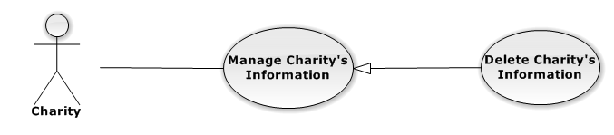

|  |  |  |  |  |
| --- | --- | --- | --- | --- |
| **USE CASE-UC012 SPECIFICATION** | | | | |
| **Use-case No.** | UC012 | **Use-case Version** | | 1.0 |
| **Use-case Name** | View News | | | |
| **Author** |  | | | |
| **Date** |  | **Priority** | High | |
| **Actor:**  **Summary:**  **Goal:**  **Triggers:**  **Preconditions:**  **Post Conditions:**  *On success:*  *On failure:*  **Main Success Scenario:**   |  |  |  | | --- | --- | --- | | **Step** | **User Action** | **System Response** | | 1. |  |  | | 2. |  |  |   **Alternative Scenario:**   |  |  |  |  | | --- | --- | --- | --- | | **No** | **Step** | **User Action** | **System Response** | | 1. | 1. |  |  | |  | 2. |  |  | | 2. | 1. |  |  | |  | 2. |  |  |   **Exceptions:**   |  |  |  | | --- | --- | --- | | **No** | **User Action** | **System Response** | | 1. |  |  | | 2. |  |  | | 3. |  |  | | 4. |  |  | | 5. |  |  |   **Relationships:**  “Manage prices” abstract use case  **Business Rules:**   |  |  | | --- | --- | | **No** | **Business Rule Description** | | 1. |  | | 2. |  | | 3. |  | | | | | |

#### Charity Manage Requests

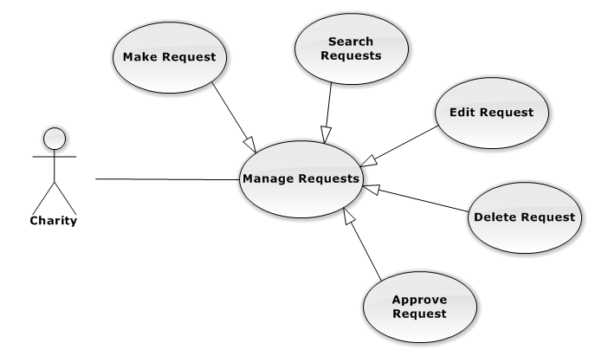

##### **CharityManage Requests – Make Request**

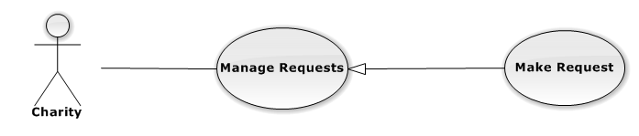

|  |  |  |  |  |
| --- | --- | --- | --- | --- |
| **USE CASE-UC013 SPECIFICATION** | | | | |
| **Use-case No.** | UC013 | **Use-case Version** | | 1.0 |
| **Use-case Name** | View News | | | |
| **Author** |  | | | |
| **Date** |  | **Priority** | High | |
| **Actor:**  **Summary:**  **Goal:**  **Triggers:**  **Preconditions:**  **Post Conditions:**  *On success:*  *On failure:*  **Main Success Scenario:**   |  |  |  | | --- | --- | --- | | **Step** | **User Action** | **System Response** | | 1. |  |  | | 2. |  |  |   **Alternative Scenario:**   |  |  |  |  | | --- | --- | --- | --- | | **No** | **Step** | **User Action** | **System Response** | | 1. | 1. |  |  | |  | 2. |  |  | | 2. | 1. |  |  | |  | 2. |  |  |   **Exceptions:**   |  |  |  | | --- | --- | --- | | **No** | **User Action** | **System Response** | | 1. |  |  | | 2. |  |  | | 3. |  |  | | 4. |  |  | | 5. |  |  |   **Relationships:**  “Manage prices” abstract use case  **Business Rules:**   |  |  | | --- | --- | | **No** | **Business Rule Description** | | 1. |  | | 2. |  | | 3. |  | | | | | |

##### **CharityManage Requests – Search Requests**

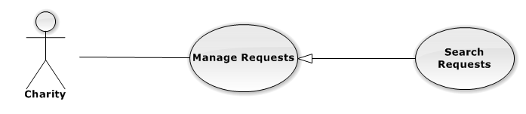

|  |  |  |  |  |
| --- | --- | --- | --- | --- |
| **USE CASE-UC014 SPECIFICATION** | | | | |
| **Use-case No.** | UC014 | **Use-case Version** | | 1.0 |
| **Use-case Name** | View News | | | |
| **Author** |  | | | |
| **Date** |  | **Priority** | High | |
| **Actor:**  **Summary:**  **Goal:**  **Triggers:**  **Preconditions:**  **Post Conditions:**  *On success:*  *On failure:*  **Main Success Scenario:**   |  |  |  | | --- | --- | --- | | **Step** | **User Action** | **System Response** | | 1. |  |  | | 2. |  |  |   **Alternative Scenario:**   |  |  |  |  | | --- | --- | --- | --- | | **No** | **Step** | **User Action** | **System Response** | | 1. | 1. |  |  | |  | 2. |  |  | | 2. | 1. |  |  | |  | 2. |  |  |   **Exceptions:**   |  |  |  | | --- | --- | --- | | **No** | **User Action** | **System Response** | | 1. |  |  | | 2. |  |  | | 3. |  |  | | 4. |  |  | | 5. |  |  |   **Relationships:**  “Manage prices” abstract use case  **Business Rules:**   |  |  | | --- | --- | | **No** | **Business Rule Description** | | 1. |  | | 2. |  | | 3. |  | | | | | |

##### **CharityManage Requests – Edit Request**

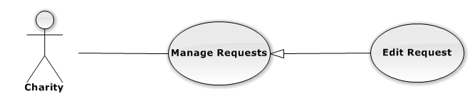

|  |  |  |  |  |
| --- | --- | --- | --- | --- |
| **USE CASE-UC015 SPECIFICATION** | | | | |
| **Use-case No.** | UC015 | **Use-case Version** | | 1.0 |
| **Use-case Name** | View News | | | |
| **Author** |  | | | |
| **Date** |  | **Priority** | High | |
| **Actor:**  **Summary:**  **Goal:**  **Triggers:**  **Preconditions:**  **Post Conditions:**  *On success:*  *On failure:*  **Main Success Scenario:**   |  |  |  | | --- | --- | --- | | **Step** | **User Action** | **System Response** | | 1. |  |  | | 2. |  |  |   **Alternative Scenario:**   |  |  |  |  | | --- | --- | --- | --- | | **No** | **Step** | **User Action** | **System Response** | | 1. | 1. |  |  | |  | 2. |  |  | | 2. | 1. |  |  | |  | 2. |  |  |   **Exceptions:**   |  |  |  | | --- | --- | --- | | **No** | **User Action** | **System Response** | | 1. |  |  | | 2. |  |  | | 3. |  |  | | 4. |  |  | | 5. |  |  |   **Relationships:**  “Manage prices” abstract use case  **Business Rules:**   |  |  | | --- | --- | | **No** | **Business Rule Description** | | 1. |  | | 2. |  | | 3. |  | | | | | |

##### **CharityManage Requests – Delete Request**

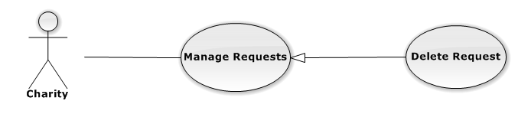

|  |  |  |  |  |
| --- | --- | --- | --- | --- |
| **USE CASE-UC016 SPECIFICATION** | | | | |
| **Use-case No.** | UC016 | **Use-case Version** | | 1.0 |
| **Use-case Name** | View News | | | |
| **Author** |  | | | |
| **Date** |  | **Priority** | High | |
| **Actor:**  **Summary:**  **Goal:**  **Triggers:**  **Preconditions:**  **Post Conditions:**  *On success:*  *On failure:*  **Main Success Scenario:**   |  |  |  | | --- | --- | --- | | **Step** | **User Action** | **System Response** | | 1. |  |  | | 2. |  |  |   **Alternative Scenario:**   |  |  |  |  | | --- | --- | --- | --- | | **No** | **Step** | **User Action** | **System Response** | | 1. | 1. |  |  | |  | 2. |  |  | | 2. | 1. |  |  | |  | 2. |  |  |   **Exceptions:**   |  |  |  | | --- | --- | --- | | **No** | **User Action** | **System Response** | | 1. |  |  | | 2. |  |  | | 3. |  |  | | 4. |  |  | | 5. |  |  |   **Relationships:**  “Manage prices” abstract use case  **Business Rules:**   |  |  | | --- | --- | | **No** | **Business Rule Description** | | 1. |  | | 2. |  | | 3. |  | | | | | |

##### **CharityManage Requests – Approve Request**

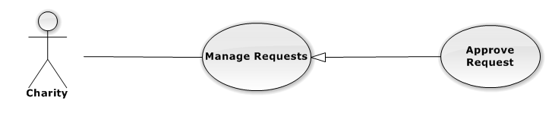

|  |  |  |  |  |
| --- | --- | --- | --- | --- |
| **USE CASE-UC017 SPECIFICATION** | | | | |
| **Use-case No.** | UC017 | **Use-case Version** | | 1.0 |
| **Use-case Name** | View News | | | |
| **Author** |  | | | |
| **Date** |  | **Priority** | High | |
| **Actor:**  **Summary:**  **Goal:**  **Triggers:**  **Preconditions:**  **Post Conditions:**  *On success:*  *On failure:*  **Main Success Scenario:**   |  |  |  | | --- | --- | --- | | **Step** | **User Action** | **System Response** | | 1. |  |  | | 2. |  |  |   **Alternative Scenario:**   |  |  |  |  | | --- | --- | --- | --- | | **No** | **Step** | **User Action** | **System Response** | | 1. | 1. |  |  | |  | 2. |  |  | | 2. | 1. |  |  | |  | 2. |  |  |   **Exceptions:**   |  |  |  | | --- | --- | --- | | **No** | **User Action** | **System Response** | | 1. |  |  | | 2. |  |  | | 3. |  |  | | 4. |  |  | | 5. |  |  |   **Relationships:**  “Manage prices” abstract use case  **Business Rules:**   |  |  | | --- | --- | | **No** | **Business Rule Description** | | 1. |  | | 2. |  | | 3. |  | | | | | |

#### Charity Manage Resources

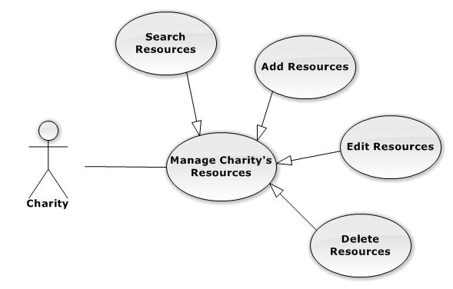

##### **CharityManage Resources – Search Resources**

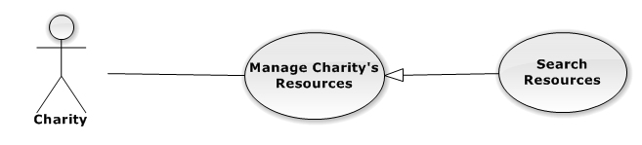

|  |  |  |  |  |
| --- | --- | --- | --- | --- |
| **USE CASE-UC018 SPECIFICATION** | | | | |
| **Use-case No.** | UC018 | **Use-case Version** | | 1.0 |
| **Use-case Name** | View News | | | |
| **Author** |  | | | |
| **Date** |  | **Priority** | High | |
| **Actor:**  **Summary:**  **Goal:**  **Triggers:**  **Preconditions:**  **Post Conditions:**  *On success:*  *On failure:*  **Main Success Scenario:**   |  |  |  | | --- | --- | --- | | **Step** | **User Action** | **System Response** | | 1. |  |  | | 2. |  |  |   **Alternative Scenario:**   |  |  |  |  | | --- | --- | --- | --- | | **No** | **Step** | **User Action** | **System Response** | | 1. | 1. |  |  | |  | 2. |  |  | | 2. | 1. |  |  | |  | 2. |  |  |   **Exceptions:**   |  |  |  | | --- | --- | --- | | **No** | **User Action** | **System Response** | | 1. |  |  | | 2. |  |  | | 3. |  |  | | 4. |  |  | | 5. |  |  |   **Relationships:**  “Manage prices” abstract use case  **Business Rules:**   |  |  | | --- | --- | | **No** | **Business Rule Description** | | 1. |  | | 2. |  | | 3. |  | | | | | |

##### **CharityManage Resources – Add Resources**

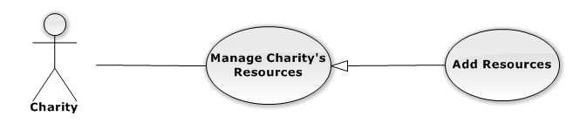

|  |  |  |  |  |
| --- | --- | --- | --- | --- |
| **USE CASE-UC019 SPECIFICATION** | | | | |
| **Use-case No.** | UC019 | **Use-case Version** | | 1.0 |
| **Use-case Name** | View News | | | |
| **Author** |  | | | |
| **Date** |  | **Priority** | High | |
| **Actor:**  **Summary:**  **Goal:**  **Triggers:**  **Preconditions:**  **Post Conditions:**  *On success:*  *On failure:*  **Main Success Scenario:**   |  |  |  | | --- | --- | --- | | **Step** | **User Action** | **System Response** | | 1. |  |  | | 2. |  |  |   **Alternative Scenario:**   |  |  |  |  | | --- | --- | --- | --- | | **No** | **Step** | **User Action** | **System Response** | | 1. | 1. |  |  | |  | 2. |  |  | | 2. | 1. |  |  | |  | 2. |  |  |   **Exceptions:**   |  |  |  | | --- | --- | --- | | **No** | **User Action** | **System Response** | | 1. |  |  | | 2. |  |  | | 3. |  |  | | 4. |  |  | | 5. |  |  |   **Relationships:**  “Manage prices” abstract use case  **Business Rules:**   |  |  | | --- | --- | | **No** | **Business Rule Description** | | 1. |  | | 2. |  | | 3. |  | | | | | |

##### **CharityManage Resources – Edit Resources**



|  |  |  |  |  |
| --- | --- | --- | --- | --- |
| **USE CASE-UC020 SPECIFICATION** | | | | |
| **Use-case No.** | UC020 | **Use-case Version** | | 1.0 |
| **Use-case Name** | View News | | | |
| **Author** |  | | | |
| **Date** |  | **Priority** | High | |
| **Actor:**  **Summary:**  **Goal:**  **Triggers:**  **Preconditions:**  **Post Conditions:**  *On success:*  *On failure:*  **Main Success Scenario:**   |  |  |  | | --- | --- | --- | | **Step** | **User Action** | **System Response** | | 1. |  |  | | 2. |  |  |   **Alternative Scenario:**   |  |  |  |  | | --- | --- | --- | --- | | **No** | **Step** | **User Action** | **System Response** | | 1. | 1. |  |  | |  | 2. |  |  | | 2. | 1. |  |  | |  | 2. |  |  |   **Exceptions:**   |  |  |  | | --- | --- | --- | | **No** | **User Action** | **System Response** | | 1. |  |  | | 2. |  |  | | 3. |  |  | | 4. |  |  | | 5. |  |  |   **Relationships:**  “Manage prices” abstract use case  **Business Rules:**   |  |  | | --- | --- | | **No** | **Business Rule Description** | | 1. |  | | 2. |  | | 3. |  | | | | | |

##### **CharityManage Resources – Delete Resources**

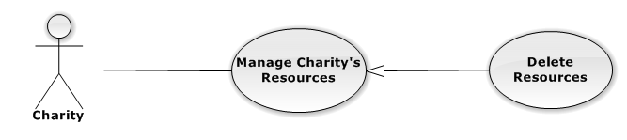

|  |  |  |  |  |
| --- | --- | --- | --- | --- |
| **USE CASE-UC021 SPECIFICATION** | | | | |
| **Use-case No.** | UC021 | **Use-case Version** | | 1.0 |
| **Use-case Name** | View News | | | |
| **Author** |  | | | |
| **Date** |  | **Priority** | High | |
| **Actor:**  **Summary:**  **Goal:**  **Triggers:**  **Preconditions:**  **Post Conditions:**  *On success:*  *On failure:*  **Main Success Scenario:**   |  |  |  | | --- | --- | --- | | **Step** | **User Action** | **System Response** | | 1. |  |  | | 2. |  |  |   **Alternative Scenario:**   |  |  |  |  | | --- | --- | --- | --- | | **No** | **Step** | **User Action** | **System Response** | | 1. | 1. |  |  | |  | 2. |  |  | | 2. | 1. |  |  | |  | 2. |  |  |   **Exceptions:**   |  |  |  | | --- | --- | --- | | **No** | **User Action** | **System Response** | | 1. |  |  | | 2. |  |  | | 3. |  |  | | 4. |  |  | | 5. |  |  |   **Relationships:**  “Manage prices” abstract use case  **Business Rules:**   |  |  | | --- | --- | | **No** | **Business Rule Description** | | 1. |  | | 2. |  | | 3. |  | | | | | |

#### Charity Manage Schedule

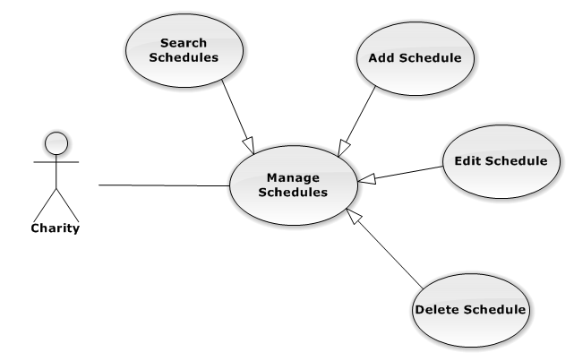

##### **CharityManage Schedule – Search Schedules**

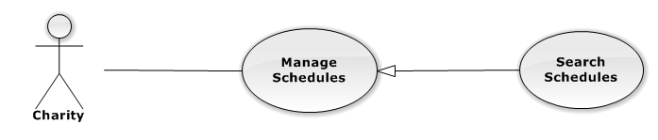

|  |  |  |  |  |
| --- | --- | --- | --- | --- |
| **USE CASE-UC022 SPECIFICATION** | | | | |
| **Use-case No.** | UC022 | **Use-case Version** | | 1.0 |
| **Use-case Name** | View News | | | |
| **Author** |  | | | |
| **Date** |  | **Priority** | High | |
| **Actor:**  **Summary:**  **Goal:**  **Triggers:**  **Preconditions:**  **Post Conditions:**  *On success:*  *On failure:*  **Main Success Scenario:**   |  |  |  | | --- | --- | --- | | **Step** | **User Action** | **System Response** | | 1. |  |  | | 2. |  |  |   **Alternative Scenario:**   |  |  |  |  | | --- | --- | --- | --- | | **No** | **Step** | **User Action** | **System Response** | | 1. | 1. |  |  | |  | 2. |  |  | | 2. | 1. |  |  | |  | 2. |  |  |   **Exceptions:**   |  |  |  | | --- | --- | --- | | **No** | **User Action** | **System Response** | | 1. |  |  | | 2. |  |  | | 3. |  |  | | 4. |  |  | | 5. |  |  |   **Relationships:**  “Manage prices” abstract use case  **Business Rules:**   |  |  | | --- | --- | | **No** | **Business Rule Description** | | 1. |  | | 2. |  | | 3. |  | | | | | |

##### **CharityManage Schedule – Add Schedule**

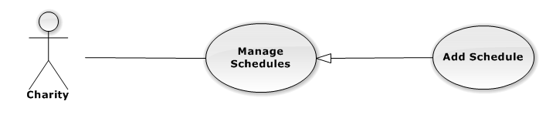

|  |  |  |  |  |
| --- | --- | --- | --- | --- |
| **USE CASE-UC023 SPECIFICATION** | | | | |
| **Use-case No.** | UC023 | **Use-case Version** | | 1.0 |
| **Use-case Name** | View News | | | |
| **Author** |  | | | |
| **Date** |  | **Priority** | High | |
| **Actor:**  **Summary:**  **Goal:**  **Triggers:**  **Preconditions:**  **Post Conditions:**  *On success:*  *On failure:*  **Main Success Scenario:**   |  |  |  | | --- | --- | --- | | **Step** | **User Action** | **System Response** | | 1. |  |  | | 2. |  |  |   **Alternative Scenario:**   |  |  |  |  | | --- | --- | --- | --- | | **No** | **Step** | **User Action** | **System Response** | | 1. | 1. |  |  | |  | 2. |  |  | | 2. | 1. |  |  | |  | 2. |  |  |   **Exceptions:**   |  |  |  | | --- | --- | --- | | **No** | **User Action** | **System Response** | | 1. |  |  | | 2. |  |  | | 3. |  |  | | 4. |  |  | | 5. |  |  |   **Relationships:**  “Manage prices” abstract use case  **Business Rules:**   |  |  | | --- | --- | | **No** | **Business Rule Description** | | 1. |  | | 2. |  | | 3. |  | | | | | |

##### **CharityManage Schedule – Edit Schedule**

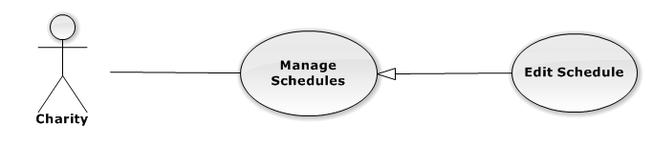

|  |  |  |  |  |
| --- | --- | --- | --- | --- |
| **USE CASE-UC024 SPECIFICATION** | | | | |
| **Use-case No.** | UC024 | **Use-case Version** | | 1.0 |
| **Use-case Name** | View News | | | |
| **Author** |  | | | |
| **Date** |  | **Priority** | High | |
| **Actor:**  **Summary:**  **Goal:**  **Triggers:**  **Preconditions:**  **Post Conditions:**  *On success:*  *On failure:*  **Main Success Scenario:**   |  |  |  | | --- | --- | --- | | **Step** | **User Action** | **System Response** | | 1. |  |  | | 2. |  |  |   **Alternative Scenario:**   |  |  |  |  | | --- | --- | --- | --- | | **No** | **Step** | **User Action** | **System Response** | | 1. | 1. |  |  | |  | 2. |  |  | | 2. | 1. |  |  | |  | 2. |  |  |   **Exceptions:**   |  |  |  | | --- | --- | --- | | **No** | **User Action** | **System Response** | | 1. |  |  | | 2. |  |  | | 3. |  |  | | 4. |  |  | | 5. |  |  |   **Relationships:**  “Manage prices” abstract use case  **Business Rules:**   |  |  | | --- | --- | | **No** | **Business Rule Description** | | 1. |  | | 2. |  | | 3. |  | | | | | |

##### **CharityManage Schedule – Delete Schedule**

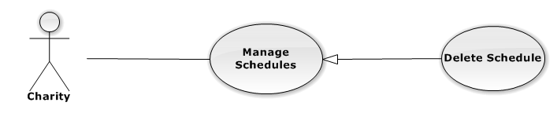

|  |  |  |  |  |
| --- | --- | --- | --- | --- |
| **USE CASE-UC025 SPECIFICATION** | | | | |
| **Use-case No.** | UC025 | **Use-case Version** | | 1.0 |
| **Use-case Name** | View News | | | |
| **Author** |  | | | |
| **Date** |  | **Priority** | High | |
| **Actor:**  **Summary:**  **Goal:**  **Triggers:**  **Preconditions:**  **Post Conditions:**  *On success:*  *On failure:*  **Main Success Scenario:**   |  |  |  | | --- | --- | --- | | **Step** | **User Action** | **System Response** | | 1. |  |  | | 2. |  |  |   **Alternative Scenario:**   |  |  |  |  | | --- | --- | --- | --- | | **No** | **Step** | **User Action** | **System Response** | | 1. | 1. |  |  | |  | 2. |  |  | | 2. | 1. |  |  | |  | 2. |  |  |   **Exceptions:**   |  |  |  | | --- | --- | --- | | **No** | **User Action** | **System Response** | | 1. |  |  | | 2. |  |  | | 3. |  |  | | 4. |  |  | | 5. |  |  |   **Relationships:**  “Manage prices” abstract use case  **Business Rules:**   |  |  | | --- | --- | | **No** | **Business Rule Description** | | 1. |  | | 2. |  | | 3. |  | | | | | |

#### Charity Pay Fees

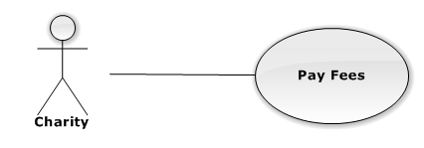

|  |  |  |  |  |
| --- | --- | --- | --- | --- |
| **USE CASE-UC026 SPECIFICATION** | | | | |
| **Use-case No.** | UC026 | **Use-case Version** | | 1.0 |
| **Use-case Name** | View News | | | |
| **Author** |  | | | |
| **Date** |  | **Priority** | High | |
| **Actor:**  **Summary:**  **Goal:**  **Triggers:**  **Preconditions:**  **Post Conditions:**  *On success:*  *On failure:*  **Main Success Scenario:**   |  |  |  | | --- | --- | --- | | **Step** | **User Action** | **System Response** | | 1. |  |  | | 2. |  |  |   **Alternative Scenario:**   |  |  |  |  | | --- | --- | --- | --- | | **No** | **Step** | **User Action** | **System Response** | | 1. | 1. |  |  | |  | 2. |  |  | | 2. | 1. |  |  | |  | 2. |  |  |   **Exceptions:**   |  |  |  | | --- | --- | --- | | **No** | **User Action** | **System Response** | | 1. |  |  | | 2. |  |  | | 3. |  |  | | 4. |  |  | | 5. |  |  |   **Relationships:**  “Manage prices” abstract use case  **Business Rules:**   |  |  | | --- | --- | | **No** | **Business Rule Description** | | 1. |  | | 2. |  | | 3. |  | | | | | |

#### Charity View Charity’s Statistics

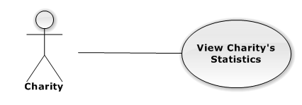

|  |  |  |  |  |
| --- | --- | --- | --- | --- |
| **USE CASE-UC027 SPECIFICATION** | | | | |
| **Use-case No.** | UC027 | **Use-case Version** | | 1.0 |
| **Use-case Name** | View News | | | |
| **Author** |  | | | |
| **Date** |  | **Priority** | High | |
| **Actor:**  **Summary:**  **Goal:**  **Triggers:**  **Preconditions:**  **Post Conditions:**  *On success:*  *On failure:*  **Main Success Scenario:**   |  |  |  | | --- | --- | --- | | **Step** | **User Action** | **System Response** | | 1. |  |  | | 2. |  |  |   **Alternative Scenario:**   |  |  |  |  | | --- | --- | --- | --- | | **No** | **Step** | **User Action** | **System Response** | | 1. | 1. |  |  | |  | 2. |  |  | | 2. | 1. |  |  | |  | 2. |  |  |   **Exceptions:**   |  |  |  | | --- | --- | --- | | **No** | **User Action** | **System Response** | | 1. |  |  | | 2. |  |  | | 3. |  |  | | 4. |  |  | | 5. |  |  |   **Relationships:**  “Manage prices” abstract use case  **Business Rules:**   |  |  | | --- | --- | | **No** | **Business Rule Description** | | 1. |  | | 2. |  | | 3. |  | | | | | |

#### Sponsor Manage Sponsor’s Resources

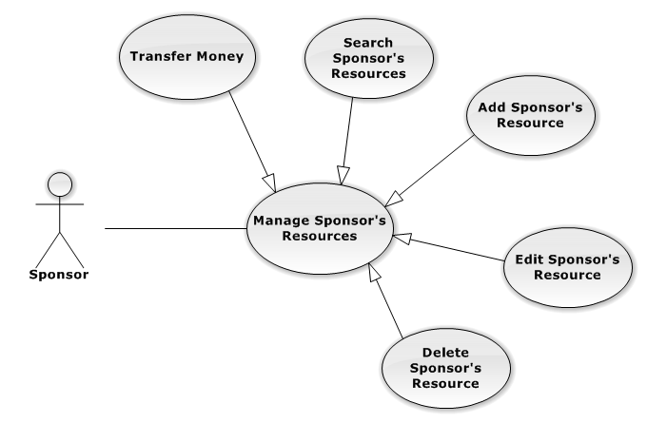

##### **SponsorManage Sponsor’s Resources – Transfer Money**

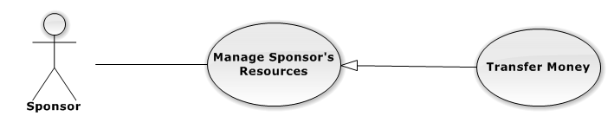

|  |  |  |  |  |
| --- | --- | --- | --- | --- |
| **USE CASE-UC028 SPECIFICATION** | | | | |
| **Use-case No.** | UC028 | **Use-case Version** | | 1.0 |
| **Use-case Name** | View News | | | |
| **Author** |  | | | |
| **Date** |  | **Priority** | High | |
| **Actor:**  **Summary:**  **Goal:**  **Triggers:**  **Preconditions:**  **Post Conditions:**  *On success:*  *On failure:*  **Main Success Scenario:**   |  |  |  | | --- | --- | --- | | **Step** | **User Action** | **System Response** | | 1. |  |  | | 2. |  |  |   **Alternative Scenario:**   |  |  |  |  | | --- | --- | --- | --- | | **No** | **Step** | **User Action** | **System Response** | | 1. | 1. |  |  | |  | 2. |  |  | | 2. | 1. |  |  | |  | 2. |  |  |   **Exceptions:**   |  |  |  | | --- | --- | --- | | **No** | **User Action** | **System Response** | | 1. |  |  | | 2. |  |  | | 3. |  |  | | 4. |  |  | | 5. |  |  |   **Relationships:**  “Manage prices” abstract use case  **Business Rules:**   |  |  | | --- | --- | | **No** | **Business Rule Description** | | 1. |  | | 2. |  | | 3. |  | | | | | |

##### **SponsorManage Sponsor’s Resources – Search Sponsor’s Resource**

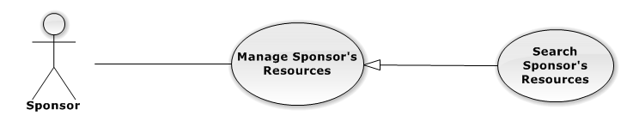

|  |  |  |  |  |
| --- | --- | --- | --- | --- |
| **USE CASE-UC029 SPECIFICATION** | | | | |
| **Use-case No.** | UC029 | **Use-case Version** | | 1.0 |
| **Use-case Name** | View News | | | |
| **Author** |  | | | |
| **Date** |  | **Priority** | High | |
| **Actor:**  **Summary:**  **Goal:**  **Triggers:**  **Preconditions:**  **Post Conditions:**  *On success:*  *On failure:*  **Main Success Scenario:**   |  |  |  | | --- | --- | --- | | **Step** | **User Action** | **System Response** | | 1. |  |  | | 2. |  |  |   **Alternative Scenario:**   |  |  |  |  | | --- | --- | --- | --- | | **No** | **Step** | **User Action** | **System Response** | | 1. | 1. |  |  | |  | 2. |  |  | | 2. | 1. |  |  | |  | 2. |  |  |   **Exceptions:**   |  |  |  | | --- | --- | --- | | **No** | **User Action** | **System Response** | | 1. |  |  | | 2. |  |  | | 3. |  |  | | 4. |  |  | | 5. |  |  |   **Relationships:**  “Manage prices” abstract use case  **Business Rules:**   |  |  | | --- | --- | | **No** | **Business Rule Description** | | 1. |  | | 2. |  | | 3. |  | | | | | |

##### **SponsorManage Sponsor’s Resources – Add Sponsor’s Resource**

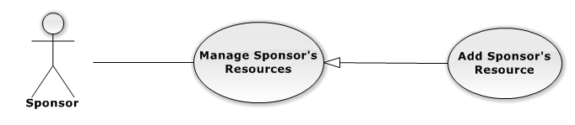

|  |  |  |  |  |
| --- | --- | --- | --- | --- |
| **USE CASE-UC030 SPECIFICATION** | | | | |
| **Use-case No.** | UC030 | **Use-case Version** | | 1.0 |
| **Use-case Name** | View News | | | |
| **Author** |  | | | |
| **Date** |  | **Priority** | High | |
| **Actor:**  **Summary:**  **Goal:**  **Triggers:**  **Preconditions:**  **Post Conditions:**  *On success:*  *On failure:*  **Main Success Scenario:**   |  |  |  | | --- | --- | --- | | **Step** | **User Action** | **System Response** | | 1. |  |  | | 2. |  |  |   **Alternative Scenario:**   |  |  |  |  | | --- | --- | --- | --- | | **No** | **Step** | **User Action** | **System Response** | | 1. | 1. |  |  | |  | 2. |  |  | | 2. | 1. |  |  | |  | 2. |  |  |   **Exceptions:**   |  |  |  | | --- | --- | --- | | **No** | **User Action** | **System Response** | | 1. |  |  | | 2. |  |  | | 3. |  |  | | 4. |  |  | | 5. |  |  |   **Relationships:**  “Manage prices” abstract use case  **Business Rules:**   |  |  | | --- | --- | | **No** | **Business Rule Description** | | 1. |  | | 2. |  | | 3. |  | | | | | |

##### **SponsorManage Sponsor’s Resources – Edit Sponsor’s Resource**

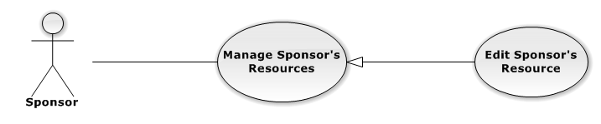

|  |  |  |  |  |
| --- | --- | --- | --- | --- |
| **USE CASE-UC031 SPECIFICATION** | | | | |
| **Use-case No.** | UC031 | **Use-case Version** | | 1.0 |
| **Use-case Name** | View News | | | |
| **Author** |  | | | |
| **Date** |  | **Priority** | High | |
| **Actor:**  **Summary:**  **Goal:**  **Triggers:**  **Preconditions:**  **Post Conditions:**  *On success:*  *On failure:*  **Main Success Scenario:**   |  |  |  | | --- | --- | --- | | **Step** | **User Action** | **System Response** | | 1. |  |  | | 2. |  |  |   **Alternative Scenario:**   |  |  |  |  | | --- | --- | --- | --- | | **No** | **Step** | **User Action** | **System Response** | | 1. | 1. |  |  | |  | 2. |  |  | | 2. | 1. |  |  | |  | 2. |  |  |   **Exceptions:**   |  |  |  | | --- | --- | --- | | **No** | **User Action** | **System Response** | | 1. |  |  | | 2. |  |  | | 3. |  |  | | 4. |  |  | | 5. |  |  |   **Relationships:**  “Manage prices” abstract use case  **Business Rules:**   |  |  | | --- | --- | | **No** | **Business Rule Description** | | 1. |  | | 2. |  | | 3. |  | | | | | |

##### **SponsorManage Sponsor’s Resources – Delete Sponsor’s Resource**

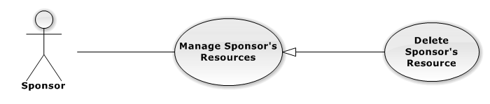

|  |  |  |  |  |
| --- | --- | --- | --- | --- |
| **USE CASE-UC032 SPECIFICATION** | | | | |
| **Use-case No.** | UC032 | **Use-case Version** | | 1.0 |
| **Use-case Name** | View News | | | |
| **Author** |  | | | |
| **Date** |  | **Priority** | High | |
| **Actor:**  **Summary:**  **Goal:**  **Triggers:**  **Preconditions:**  **Post Conditions:**  *On success:*  *On failure:*  **Main Success Scenario:**   |  |  |  | | --- | --- | --- | | **Step** | **User Action** | **System Response** | | 1. |  |  | | 2. |  |  |   **Alternative Scenario:**   |  |  |  |  | | --- | --- | --- | --- | | **No** | **Step** | **User Action** | **System Response** | | 1. | 1. |  |  | |  | 2. |  |  | | 2. | 1. |  |  | |  | 2. |  |  |   **Exceptions:**   |  |  |  | | --- | --- | --- | | **No** | **User Action** | **System Response** | | 1. |  |  | | 2. |  |  | | 3. |  |  | | 4. |  |  | | 5. |  |  |   **Relationships:**  “Manage prices” abstract use case  **Business Rules:**   |  |  | | --- | --- | | **No** | **Business Rule Description** | | 1. |  | | 2. |  | | 3. |  | | | | | |

#### Sponsor Search Charities

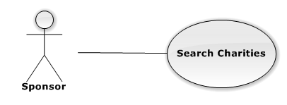

|  |  |  |  |  |
| --- | --- | --- | --- | --- |
| **USE CASE-UC033 SPECIFICATION** | | | | |
| **Use-case No.** | UC033 | **Use-case Version** | | 1.0 |
| **Use-case Name** | View News | | | |
| **Author** |  | | | |
| **Date** |  | **Priority** | High | |
| **Actor:**  **Summary:**  **Goal:**  **Triggers:**  **Preconditions:**  **Post Conditions:**  *On success:*  *On failure:*  **Main Success Scenario:**   |  |  |  | | --- | --- | --- | | **Step** | **User Action** | **System Response** | | 1. |  |  | | 2. |  |  |   **Alternative Scenario:**   |  |  |  |  | | --- | --- | --- | --- | | **No** | **Step** | **User Action** | **System Response** | | 1. | 1. |  |  | |  | 2. |  |  | | 2. | 1. |  |  | |  | 2. |  |  |   **Exceptions:**   |  |  |  | | --- | --- | --- | | **No** | **User Action** | **System Response** | | 1. |  |  | | 2. |  |  | | 3. |  |  | | 4. |  |  | | 5. |  |  |   **Relationships:**  “Manage prices” abstract use case  **Business Rules:**   |  |  | | --- | --- | | **No** | **Business Rule Description** | | 1. |  | | 2. |  | | 3. |  | | | | | |

#### Sponsor View Sponsor’s Statistics

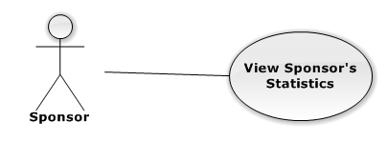

|  |  |  |  |  |
| --- | --- | --- | --- | --- |
| **USE CASE-UC034 SPECIFICATION** | | | | |
| **Use-case No.** | UC034 | **Use-case Version** | | 1.0 |
| **Use-case Name** | View News | | | |
| **Author** |  | | | |
| **Date** |  | **Priority** | High | |
| **Actor:**  **Summary:**  **Goal:**  **Triggers:**  **Preconditions:**  **Post Conditions:**  *On success:*  *On failure:*  **Main Success Scenario:**   |  |  |  | | --- | --- | --- | | **Step** | **User Action** | **System Response** | | 1. |  |  | | 2. |  |  |   **Alternative Scenario:**   |  |  |  |  | | --- | --- | --- | --- | | **No** | **Step** | **User Action** | **System Response** | | 1. | 1. |  |  | |  | 2. |  |  | | 2. | 1. |  |  | |  | 2. |  |  |   **Exceptions:**   |  |  |  | | --- | --- | --- | | **No** | **User Action** | **System Response** | | 1. |  |  | | 2. |  |  | | 3. |  |  | | 4. |  |  | | 5. |  |  |   **Relationships:**  “Manage prices” abstract use case  **Business Rules:**   |  |  | | --- | --- | | **No** | **Business Rule Description** | | 1. |  | | 2. |  | | 3. |  | | | | | |

#### Volunteer Manage News

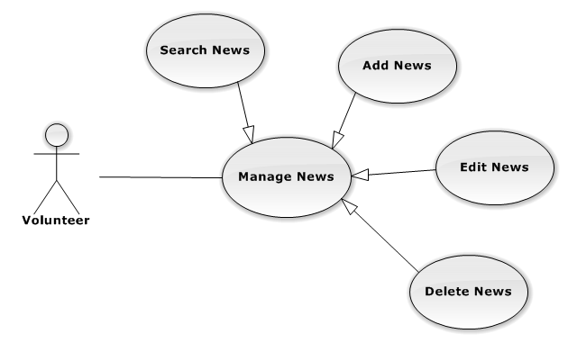

##### **VolunteerManage News – Search News**



|  |  |  |  |  |
| --- | --- | --- | --- | --- |
| **USE CASE-UC035 SPECIFICATION** | | | | |
| **Use-case No.** | UC035 | **Use-case Version** | | 1.0 |
| **Use-case Name** | View News | | | |
| **Author** |  | | | |
| **Date** |  | **Priority** | High | |
| **Actor:**  **Summary:**  **Goal:**  **Triggers:**  **Preconditions:**  **Post Conditions:**  *On success:*  *On failure:*  **Main Success Scenario:**   |  |  |  | | --- | --- | --- | | **Step** | **User Action** | **System Response** | | 1. |  |  | | 2. |  |  |   **Alternative Scenario:**   |  |  |  |  | | --- | --- | --- | --- | | **No** | **Step** | **User Action** | **System Response** | | 1. | 1. |  |  | |  | 2. |  |  | | 2. | 1. |  |  | |  | 2. |  |  |   **Exceptions:**   |  |  |  | | --- | --- | --- | | **No** | **User Action** | **System Response** | | 1. |  |  | | 2. |  |  | | 3. |  |  | | 4. |  |  | | 5. |  |  |   **Relationships:**  “Manage prices” abstract use case  **Business Rules:**   |  |  | | --- | --- | | **No** | **Business Rule Description** | | 1. |  | | 2. |  | | 3. |  | | | | | |

##### **VolunteerManage News – Add News**



|  |  |  |  |  |
| --- | --- | --- | --- | --- |
| **USE CASE-UC036 SPECIFICATION** | | | | |
| **Use-case No.** | UC036 | **Use-case Version** | | 1.0 |
| **Use-case Name** | View News | | | |
| **Author** |  | | | |
| **Date** |  | **Priority** | High | |
| **Actor:**  **Summary:**  **Goal:**  **Triggers:**  **Preconditions:**  **Post Conditions:**  *On success:*  *On failure:*  **Main Success Scenario:**   |  |  |  | | --- | --- | --- | | **Step** | **User Action** | **System Response** | | 1. |  |  | | 2. |  |  |   **Alternative Scenario:**   |  |  |  |  | | --- | --- | --- | --- | | **No** | **Step** | **User Action** | **System Response** | | 1. | 1. |  |  | |  | 2. |  |  | | 2. | 1. |  |  | |  | 2. |  |  |   **Exceptions:**   |  |  |  | | --- | --- | --- | | **No** | **User Action** | **System Response** | | 1. |  |  | | 2. |  |  | | 3. |  |  | | 4. |  |  | | 5. |  |  |   **Relationships:**  “Manage prices” abstract use case  **Business Rules:**   |  |  | | --- | --- | | **No** | **Business Rule Description** | | 1. |  | | 2. |  | | 3. |  | | | | | |

##### **VolunteerManage News – Edit News**



|  |  |  |  |  |
| --- | --- | --- | --- | --- |
| **USE CASE-UC037 SPECIFICATION** | | | | |
| **Use-case No.** | UC037 | **Use-case Version** | | 1.0 |
| **Use-case Name** | View News | | | |
| **Author** |  | | | |
| **Date** |  | **Priority** | High | |
| **Actor:**  **Summary:**  **Goal:**  **Triggers:**  **Preconditions:**  **Post Conditions:**  *On success:*  *On failure:*  **Main Success Scenario:**   |  |  |  | | --- | --- | --- | | **Step** | **User Action** | **System Response** | | 1. |  |  | | 2. |  |  |   **Alternative Scenario:**   |  |  |  |  | | --- | --- | --- | --- | | **No** | **Step** | **User Action** | **System Response** | | 1. | 1. |  |  | |  | 2. |  |  | | 2. | 1. |  |  | |  | 2. |  |  |   **Exceptions:**   |  |  |  | | --- | --- | --- | | **No** | **User Action** | **System Response** | | 1. |  |  | | 2. |  |  | | 3. |  |  | | 4. |  |  | | 5. |  |  |   **Relationships:**  “Manage prices” abstract use case  **Business Rules:**   |  |  | | --- | --- | | **No** | **Business Rule Description** | | 1. |  | | 2. |  | | 3. |  | | | | | |

##### **VolunteerManage News – Delete News**



|  |  |  |  |  |
| --- | --- | --- | --- | --- |
| **USE CASE-UC038 SPECIFICATION** | | | | |
| **Use-case No.** | UC038 | **Use-case Version** | | 1.0 |
| **Use-case Name** | View News | | | |
| **Author** |  | | | |
| **Date** |  | **Priority** | High | |
| **Actor:**  **Summary:**  **Goal:**  **Triggers:**  **Preconditions:**  **Post Conditions:**  *On success:*  *On failure:*  **Main Success Scenario:**   |  |  |  | | --- | --- | --- | | **Step** | **User Action** | **System Response** | | 1. |  |  | | 2. |  |  |   **Alternative Scenario:**   |  |  |  |  | | --- | --- | --- | --- | | **No** | **Step** | **User Action** | **System Response** | | 1. | 1. |  |  | |  | 2. |  |  | | 2. | 1. |  |  | |  | 2. |  |  |   **Exceptions:**   |  |  |  | | --- | --- | --- | | **No** | **User Action** | **System Response** | | 1. |  |  | | 2. |  |  | | 3. |  |  | | 4. |  |  | | 5. |  |  |   **Relationships:**  “Manage prices” abstract use case  **Business Rules:**   |  |  | | --- | --- | | **No** | **Business Rule Description** | | 1. |  | | 2. |  | | 3. |  | | | | | |

#### Volunteer View Request

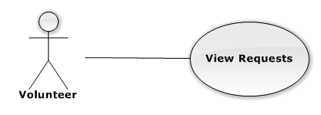

|  |  |  |  |  |
| --- | --- | --- | --- | --- |
| **USE CASE-UC039 SPECIFICATION** | | | | |
| **Use-case No.** | UC039 | **Use-case Version** | | 1.0 |
| **Use-case Name** | View News | | | |
| **Author** |  | | | |
| **Date** |  | **Priority** | High | |
| **Actor:**  **Summary:**  **Goal:**  **Triggers:**  **Preconditions:**  **Post Conditions:**  *On success:*  *On failure:*  **Main Success Scenario:**   |  |  |  | | --- | --- | --- | | **Step** | **User Action** | **System Response** | | 1. |  |  | | 2. |  |  |   **Alternative Scenario:**   |  |  |  |  | | --- | --- | --- | --- | | **No** | **Step** | **User Action** | **System Response** | | 1. | 1. |  |  | |  | 2. |  |  | | 2. | 1. |  |  | |  | 2. |  |  |   **Exceptions:**   |  |  |  | | --- | --- | --- | | **No** | **User Action** | **System Response** | | 1. |  |  | | 2. |  |  | | 3. |  |  | | 4. |  |  | | 5. |  |  |   **Relationships:**  “Manage prices” abstract use case  **Business Rules:**   |  |  | | --- | --- | | **No** | **Business Rule Description** | | 1. |  | | 2. |  | | 3. |  | | | | | |

#### Volunteer View Schedule

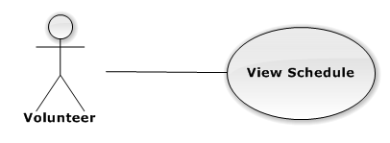

|  |  |  |  |  |
| --- | --- | --- | --- | --- |
| **USE CASE-UC040 SPECIFICATION** | | | | |
| **Use-case No.** | UC040 | **Use-case Version** | | 1.0 |
| **Use-case Name** | View News | | | |
| **Author** |  | | | |
| **Date** |  | **Priority** | High | |
| **Actor:**  **Summary:**  **Goal:**  **Triggers:**  **Preconditions:**  **Post Conditions:**  *On success:*  *On failure:*  **Main Success Scenario:**   |  |  |  | | --- | --- | --- | | **Step** | **User Action** | **System Response** | | 1. |  |  | | 2. |  |  |   **Alternative Scenario:**   |  |  |  |  | | --- | --- | --- | --- | | **No** | **Step** | **User Action** | **System Response** | | 1. | 1. |  |  | |  | 2. |  |  | | 2. | 1. |  |  | |  | 2. |  |  |   **Exceptions:**   |  |  |  | | --- | --- | --- | | **No** | **User Action** | **System Response** | | 1. |  |  | | 2. |  |  | | 3. |  |  | | 4. |  |  | | 5. |  |  |   **Relationships:**  “Manage prices” abstract use case  **Business Rules:**   |  |  | | --- | --- | | **No** | **Business Rule Description** | | 1. |  | | 2. |  | | 3. |  | | | | | |

#### Candidate Manage Candidate’s Request

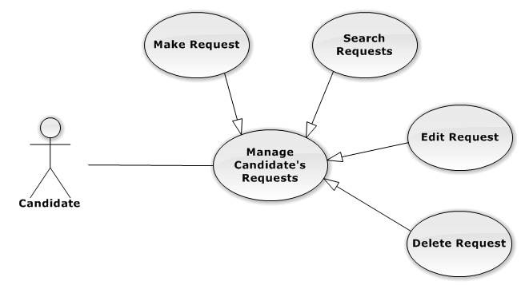

##### **CandidateManage Candidate’s Request – Make Request**

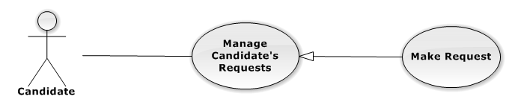

|  |  |  |  |  |
| --- | --- | --- | --- | --- |
| **USE CASE-UC041 SPECIFICATION** | | | | |
| **Use-case No.** | UC041 | **Use-case Version** | | 1.0 |
| **Use-case Name** | View News | | | |
| **Author** |  | | | |
| **Date** |  | **Priority** | High | |
| **Actor:**  **Summary:**  **Goal:**  **Triggers:**  **Preconditions:**  **Post Conditions:**  *On success:*  *On failure:*  **Main Success Scenario:**   |  |  |  | | --- | --- | --- | | **Step** | **User Action** | **System Response** | | 1. |  |  | | 2. |  |  |   **Alternative Scenario:**   |  |  |  |  | | --- | --- | --- | --- | | **No** | **Step** | **User Action** | **System Response** | | 1. | 1. |  |  | |  | 2. |  |  | | 2. | 1. |  |  | |  | 2. |  |  |   **Exceptions:**   |  |  |  | | --- | --- | --- | | **No** | **User Action** | **System Response** | | 1. |  |  | | 2. |  |  | | 3. |  |  | | 4. |  |  | | 5. |  |  |   **Relationships:**  “Manage prices” abstract use case  **Business Rules:**   |  |  | | --- | --- | | **No** | **Business Rule Description** | | 1. |  | | 2. |  | | 3. |  | | | | | |

##### **CandidateManage Candidate’s Request – Search Requests**

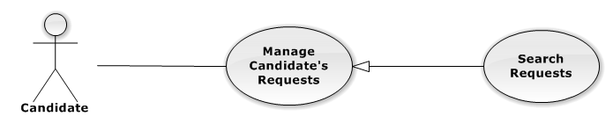

|  |  |  |  |  |
| --- | --- | --- | --- | --- |
| **USE CASE-UC042 SPECIFICATION** | | | | |
| **Use-case No.** | UC042 | **Use-case Version** | | 1.0 |
| **Use-case Name** | View News | | | |
| **Author** |  | | | |
| **Date** |  | **Priority** | High | |
| **Actor:**  **Summary:**  **Goal:**  **Triggers:**  **Preconditions:**  **Post Conditions:**  *On success:*  *On failure:*  **Main Success Scenario:**   |  |  |  | | --- | --- | --- | | **Step** | **User Action** | **System Response** | | 1. |  |  | | 2. |  |  |   **Alternative Scenario:**   |  |  |  |  | | --- | --- | --- | --- | | **No** | **Step** | **User Action** | **System Response** | | 1. | 1. |  |  | |  | 2. |  |  | | 2. | 1. |  |  | |  | 2. |  |  |   **Exceptions:**   |  |  |  | | --- | --- | --- | | **No** | **User Action** | **System Response** | | 1. |  |  | | 2. |  |  | | 3. |  |  | | 4. |  |  | | 5. |  |  |   **Relationships:**  “Manage prices” abstract use case  **Business Rules:**   |  |  | | --- | --- | | **No** | **Business Rule Description** | | 1. |  | | 2. |  | | 3. |  | | | | | |

##### **CandidateManage Candidate’s Request – Edit Request**

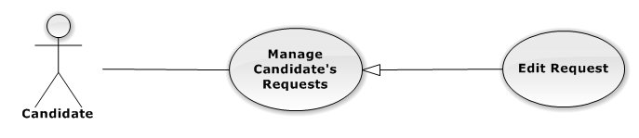

|  |  |  |  |  |
| --- | --- | --- | --- | --- |
| **USE CASE-UC043 SPECIFICATION** | | | | |
| **Use-case No.** | UC043 | **Use-case Version** | | 1.0 |
| **Use-case Name** | View News | | | |
| **Author** |  | | | |
| **Date** |  | **Priority** | High | |
| **Actor:**  **Summary:**  **Goal:**  **Triggers:**  **Preconditions:**  **Post Conditions:**  *On success:*  *On failure:*  **Main Success Scenario:**   |  |  |  | | --- | --- | --- | | **Step** | **User Action** | **System Response** | | 1. |  |  | | 2. |  |  |   **Alternative Scenario:**   |  |  |  |  | | --- | --- | --- | --- | | **No** | **Step** | **User Action** | **System Response** | | 1. | 1. |  |  | |  | 2. |  |  | | 2. | 1. |  |  | |  | 2. |  |  |   **Exceptions:**   |  |  |  | | --- | --- | --- | | **No** | **User Action** | **System Response** | | 1. |  |  | | 2. |  |  | | 3. |  |  | | 4. |  |  | | 5. |  |  |   **Relationships:**  “Manage prices” abstract use case  **Business Rules:**   |  |  | | --- | --- | | **No** | **Business Rule Description** | | 1. |  | | 2. |  | | 3. |  | | | | | |

##### **CandidateManage Candidate’s Request – Delete Request**

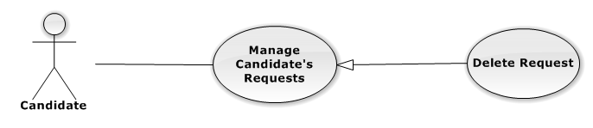

|  |  |  |  |  |
| --- | --- | --- | --- | --- |
| **USE CASE-UC044 SPECIFICATION** | | | | |
| **Use-case No.** | UC044 | **Use-case Version** | | 1.0 |
| **Use-case Name** | View News | | | |
| **Author** |  | | | |
| **Date** |  | **Priority** | High | |
| **Actor:**  **Summary:**  **Goal:**  **Triggers:**  **Preconditions:**  **Post Conditions:**  *On success:*  *On failure:*  **Main Success Scenario:**   |  |  |  | | --- | --- | --- | | **Step** | **User Action** | **System Response** | | 1. |  |  | | 2. |  |  |   **Alternative Scenario:**   |  |  |  |  | | --- | --- | --- | --- | | **No** | **Step** | **User Action** | **System Response** | | 1. | 1. |  |  | |  | 2. |  |  | | 2. | 1. |  |  | |  | 2. |  |  |   **Exceptions:**   |  |  |  | | --- | --- | --- | | **No** | **User Action** | **System Response** | | 1. |  |  | | 2. |  |  | | 3. |  |  | | 4. |  |  | | 5. |  |  |   **Relationships:**  “Manage prices” abstract use case  **Business Rules:**   |  |  | | --- | --- | | **No** | **Business Rule Description** | | 1. |  | | 2. |  | | 3. |  | | | | | |

#### Candidate View Schedule

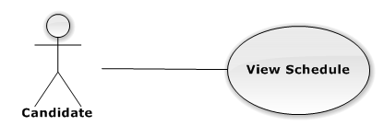

|  |  |  |  |  |
| --- | --- | --- | --- | --- |
| **USE CASE-UC045 SPECIFICATION** | | | | |
| **Use-case No.** | UC045 | **Use-case Version** | | 1.0 |
| **Use-case Name** | View News | | | |
| **Author** |  | | | |
| **Date** |  | **Priority** | High | |
| **Actor:**  **Summary:**  **Goal:**  **Triggers:**  **Preconditions:**  **Post Conditions:**  *On success:*  *On failure:*  **Main Success Scenario:**   |  |  |  | | --- | --- | --- | | **Step** | **User Action** | **System Response** | | 1. |  |  | | 2. |  |  |   **Alternative Scenario:**   |  |  |  |  | | --- | --- | --- | --- | | **No** | **Step** | **User Action** | **System Response** | | 1. | 1. |  |  | |  | 2. |  |  | | 2. | 1. |  |  | |  | 2. |  |  |   **Exceptions:**   |  |  |  | | --- | --- | --- | | **No** | **User Action** | **System Response** | | 1. |  |  | | 2. |  |  | | 3. |  |  | | 4. |  |  | | 5. |  |  |   **Relationships:**  “Manage prices” abstract use case  **Business Rules:**   |  |  | | --- | --- | | **No** | **Business Rule Description** | | 1. |  | | 2. |  | | 3. |  | | | | | |

#### Candidate Search Resources

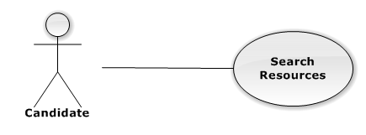

|  |  |  |  |  |
| --- | --- | --- | --- | --- |
| **USE CASE-UC046 SPECIFICATION** | | | | |
| **Use-case No.** | UC046 | **Use-case Version** | | 1.0 |
| **Use-case Name** | View News | | | |
| **Author** |  | | | |
| **Date** |  | **Priority** | High | |
| **Actor:**  **Summary:**  **Goal:**  **Triggers:**  **Preconditions:**  **Post Conditions:**  *On success:*  *On failure:*  **Main Success Scenario:**   |  |  |  | | --- | --- | --- | | **Step** | **User Action** | **System Response** | | 1. |  |  | | 2. |  |  |   **Alternative Scenario:**   |  |  |  |  | | --- | --- | --- | --- | | **No** | **Step** | **User Action** | **System Response** | | 1. | 1. |  |  | |  | 2. |  |  | | 2. | 1. |  |  | |  | 2. |  |  |   **Exceptions:**   |  |  |  | | --- | --- | --- | | **No** | **User Action** | **System Response** | | 1. |  |  | | 2. |  |  | | 3. |  |  | | 4. |  |  | | 5. |  |  |   **Relationships:**  “Manage prices” abstract use case  **Business Rules:**   |  |  | | --- | --- | | **No** | **Business Rule Description** | | 1. |  | | 2. |  | | 3. |  | | | | | |

#### Admin Manage Banner

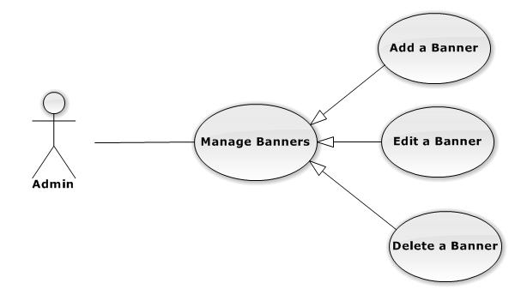

##### **AdminManage Banner – Add a banner**

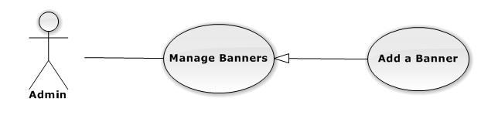

|  |  |  |  |  |
| --- | --- | --- | --- | --- |
| **USE CASE-UC047 SPECIFICATION** | | | | |
| **Use-case No.** | UC047 | **Use-case Version** | | 1.0 |
| **Use-case Name** | View News | | | |
| **Author** |  | | | |
| **Date** |  | **Priority** | High | |
| **Actor:**  **Summary:**  **Goal:**  **Triggers:**  **Preconditions:**  **Post Conditions:**  *On success:*  *On failure:*  **Main Success Scenario:**   |  |  |  | | --- | --- | --- | | **Step** | **User Action** | **System Response** | | 1. |  |  | | 2. |  |  |   **Alternative Scenario:**   |  |  |  |  | | --- | --- | --- | --- | | **No** | **Step** | **User Action** | **System Response** | | 1. | 1. |  |  | |  | 2. |  |  | | 2. | 1. |  |  | |  | 2. |  |  |   **Exceptions:**   |  |  |  | | --- | --- | --- | | **No** | **User Action** | **System Response** | | 1. |  |  | | 2. |  |  | | 3. |  |  | | 4. |  |  | | 5. |  |  |   **Relationships:**  “Manage prices” abstract use case  **Business Rules:**   |  |  | | --- | --- | | **No** | **Business Rule Description** | | 1. |  | | 2. |  | | 3. |  | | | | | |

##### **AdminManage Banner – Edit a banner**

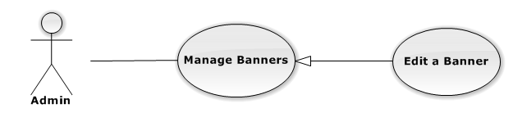

|  |  |  |  |  |
| --- | --- | --- | --- | --- |
| **USE CASE-UC048 SPECIFICATION** | | | | |
| **Use-case No.** | UC048 | **Use-case Version** | | 1.0 |
| **Use-case Name** | View News | | | |
| **Author** |  | | | |
| **Date** |  | **Priority** | High | |
| **Actor:**  **Summary:**  **Goal:**  **Triggers:**  **Preconditions:**  **Post Conditions:**  *On success:*  *On failure:*  **Main Success Scenario:**   |  |  |  | | --- | --- | --- | | **Step** | **User Action** | **System Response** | | 1. |  |  | | 2. |  |  |   **Alternative Scenario:**   |  |  |  |  | | --- | --- | --- | --- | | **No** | **Step** | **User Action** | **System Response** | | 1. | 1. |  |  | |  | 2. |  |  | | 2. | 1. |  |  | |  | 2. |  |  |   **Exceptions:**   |  |  |  | | --- | --- | --- | | **No** | **User Action** | **System Response** | | 1. |  |  | | 2. |  |  | | 3. |  |  | | 4. |  |  | | 5. |  |  |   **Relationships:**  “Manage prices” abstract use case  **Business Rules:**   |  |  | | --- | --- | | **No** | **Business Rule Description** | | 1. |  | | 2. |  | | 3. |  | | | | | |

##### **AdminManage Advertising – Delete a banner**

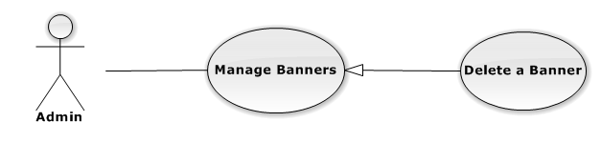

|  |  |  |  |  |
| --- | --- | --- | --- | --- |
| **USE CASE-UC049 SPECIFICATION** | | | | |
| **Use-case No.** | UC049 | **Use-case Version** | | 1.0 |
| **Use-case Name** | View News | | | |
| **Author** |  | | | |
| **Date** |  | **Priority** | High | |
| **Actor:**  **Summary:**  **Goal:**  **Triggers:**  **Preconditions:**  **Post Conditions:**  *On success:*  *On failure:*  **Main Success Scenario:**   |  |  |  | | --- | --- | --- | | **Step** | **User Action** | **System Response** | | 1. |  |  | | 2. |  |  |   **Alternative Scenario:**   |  |  |  |  | | --- | --- | --- | --- | | **No** | **Step** | **User Action** | **System Response** | | 1. | 1. |  |  | |  | 2. |  |  | | 2. | 1. |  |  | |  | 2. |  |  |   **Exceptions:**   |  |  |  | | --- | --- | --- | | **No** | **User Action** | **System Response** | | 1. |  |  | | 2. |  |  | | 3. |  |  | | 4. |  |  | | 5. |  |  |   **Relationships:**  “Manage prices” abstract use case  **Business Rules:**   |  |  | | --- | --- | | **No** | **Business Rule Description** | | 1. |  | | 2. |  | | 3. |  | | | | | |

#### Admin Manage Exam’s Information

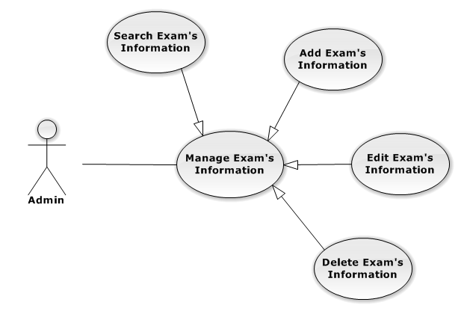

##### **AdminManage Exam’s Information – Search Exam’s Information**

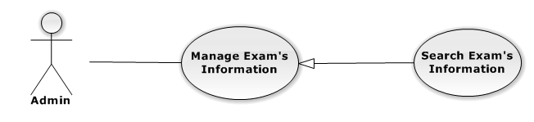

|  |  |  |  |  |
| --- | --- | --- | --- | --- |
| **USE CASE-UC050 SPECIFICATION** | | | | |
| **Use-case No.** | UC050 | **Use-case Version** | | 1.0 |
| **Use-case Name** | View News | | | |
| **Author** |  | | | |
| **Date** |  | **Priority** | High | |
| **Actor:**  **Summary:**  **Goal:**  **Triggers:**  **Preconditions:**  **Post Conditions:**  *On success:*  *On failure:*  **Main Success Scenario:**   |  |  |  | | --- | --- | --- | | **Step** | **User Action** | **System Response** | | 1. |  |  | | 2. |  |  |   **Alternative Scenario:**   |  |  |  |  | | --- | --- | --- | --- | | **No** | **Step** | **User Action** | **System Response** | | 1. | 1. |  |  | |  | 2. |  |  | | 2. | 1. |  |  | |  | 2. |  |  |   **Exceptions:**   |  |  |  | | --- | --- | --- | | **No** | **User Action** | **System Response** | | 1. |  |  | | 2. |  |  | | 3. |  |  | | 4. |  |  | | 5. |  |  |   **Relationships:**  “Manage prices” abstract use case  **Business Rules:**   |  |  | | --- | --- | | **No** | **Business Rule Description** | | 1. |  | | 2. |  | | 3. |  | | | | | |

##### **AdminManage Exam’s Information – Add Exam’s Information**

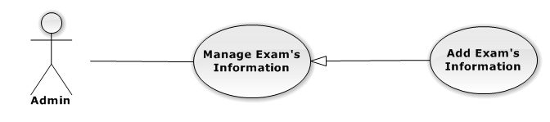

|  |  |  |  |  |
| --- | --- | --- | --- | --- |
| **USE CASE-UC051 SPECIFICATION** | | | | |
| **Use-case No.** | UC051 | **Use-case Version** | | 1.0 |
| **Use-case Name** | View News | | | |
| **Author** |  | | | |
| **Date** |  | **Priority** | High | |
| **Actor:**  **Summary:**  **Goal:**  **Triggers:**  **Preconditions:**  **Post Conditions:**  *On success:*  *On failure:*  **Main Success Scenario:**   |  |  |  | | --- | --- | --- | | **Step** | **User Action** | **System Response** | | 1. |  |  | | 2. |  |  |   **Alternative Scenario:**   |  |  |  |  | | --- | --- | --- | --- | | **No** | **Step** | **User Action** | **System Response** | | 1. | 1. |  |  | |  | 2. |  |  | | 2. | 1. |  |  | |  | 2. |  |  |   **Exceptions:**   |  |  |  | | --- | --- | --- | | **No** | **User Action** | **System Response** | | 1. |  |  | | 2. |  |  | | 3. |  |  | | 4. |  |  | | 5. |  |  |   **Relationships:**  “Manage prices” abstract use case  **Business Rules:**   |  |  | | --- | --- | | **No** | **Business Rule Description** | | 1. |  | | 2. |  | | 3. |  | | | | | |

##### **AdminManage Exam’s Information – Edit Exam’s Information**

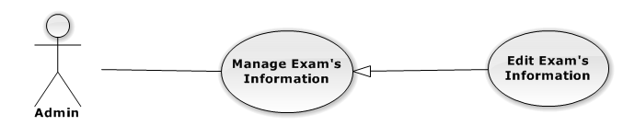

|  |  |  |  |  |
| --- | --- | --- | --- | --- |
| **USE CASE-UC052 SPECIFICATION** | | | | |
| **Use-case No.** | UC052 | **Use-case Version** | | 1.0 |
| **Use-case Name** | View News | | | |
| **Author** |  | | | |
| **Date** |  | **Priority** | High | |
| **Actor:**  **Summary:**  **Goal:**  **Triggers:**  **Preconditions:**  **Post Conditions:**  *On success:*  *On failure:*  **Main Success Scenario:**   |  |  |  | | --- | --- | --- | | **Step** | **User Action** | **System Response** | | 1. |  |  | | 2. |  |  |   **Alternative Scenario:**   |  |  |  |  | | --- | --- | --- | --- | | **No** | **Step** | **User Action** | **System Response** | | 1. | 1. |  |  | |  | 2. |  |  | | 2. | 1. |  |  | |  | 2. |  |  |   **Exceptions:**   |  |  |  | | --- | --- | --- | | **No** | **User Action** | **System Response** | | 1. |  |  | | 2. |  |  | | 3. |  |  | | 4. |  |  | | 5. |  |  |   **Relationships:**  “Manage prices” abstract use case  **Business Rules:**   |  |  | | --- | --- | | **No** | **Business Rule Description** | | 1. |  | | 2. |  | | 3. |  | | | | | |

##### **AdminManage Exam’s Information – Delete Exam’s Information**

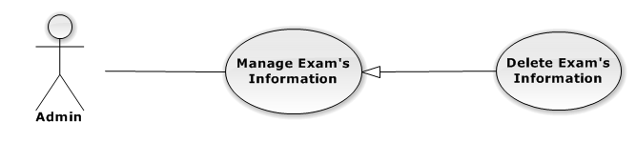

|  |  |  |  |  |
| --- | --- | --- | --- | --- |
| **USE CASE-UC053 SPECIFICATION** | | | | |
| **Use-case No.** | UC053 | **Use-case Version** | | 1.0 |
| **Use-case Name** | View News | | | |
| **Author** |  | | | |
| **Date** |  | **Priority** | High | |
| **Actor:**  **Summary:**  **Goal:**  **Triggers:**  **Preconditions:**  **Post Conditions:**  *On success:*  *On failure:*  **Main Success Scenario:**   |  |  |  | | --- | --- | --- | | **Step** | **User Action** | **System Response** | | 1. |  |  | | 2. |  |  |   **Alternative Scenario:**   |  |  |  |  | | --- | --- | --- | --- | | **No** | **Step** | **User Action** | **System Response** | | 1. | 1. |  |  | |  | 2. |  |  | | 2. | 1. |  |  | |  | 2. |  |  |   **Exceptions:**   |  |  |  | | --- | --- | --- | | **No** | **User Action** | **System Response** | | 1. |  |  | | 2. |  |  | | 3. |  |  | | 4. |  |  | | 5. |  |  |   **Relationships:**  “Manage prices” abstract use case  **Business Rules:**   |  |  | | --- | --- | | **No** | **Business Rule Description** | | 1. |  | | 2. |  | | 3. |  | | | | | |

#### Admin Manage News

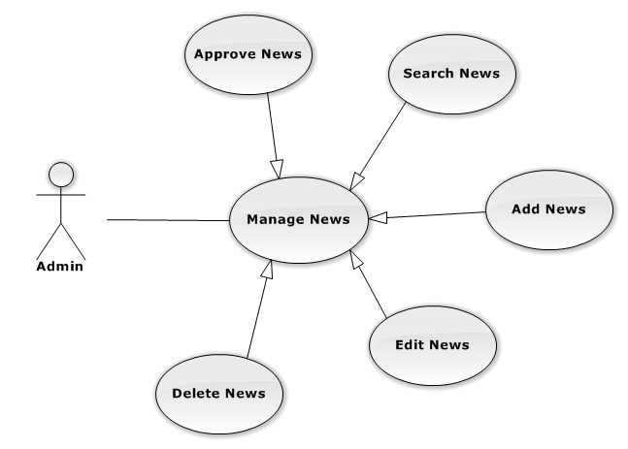

##### **AdminManage News – Approve News**

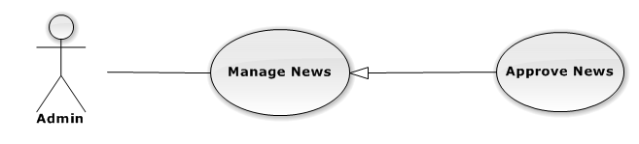

|  |  |  |  |  |
| --- | --- | --- | --- | --- |
| **USE CASE-UC054 SPECIFICATION** | | | | |
| **Use-case No.** | UC054 | **Use-case Version** | | 1.0 |
| **Use-case Name** | View News | | | |
| **Author** |  | | | |
| **Date** |  | **Priority** | High | |
| **Actor:**  **Summary:**  **Goal:**  **Triggers:**  **Preconditions:**  **Post Conditions:**  *On success:*  *On failure:*  **Main Success Scenario:**   |  |  |  | | --- | --- | --- | | **Step** | **User Action** | **System Response** | | 1. |  |  | | 2. |  |  |   **Alternative Scenario:**   |  |  |  |  | | --- | --- | --- | --- | | **No** | **Step** | **User Action** | **System Response** | | 1. | 1. |  |  | |  | 2. |  |  | | 2. | 1. |  |  | |  | 2. |  |  |   **Exceptions:**   |  |  |  | | --- | --- | --- | | **No** | **User Action** | **System Response** | | 1. |  |  | | 2. |  |  | | 3. |  |  | | 4. |  |  | | 5. |  |  |   **Relationships:**  “Manage prices” abstract use case  **Business Rules:**   |  |  | | --- | --- | | **No** | **Business Rule Description** | | 1. |  | | 2. |  | | 3. |  | | | | | |

##### **AdminManage News – Search News**



|  |  |  |  |  |
| --- | --- | --- | --- | --- |
| **USE CASE-UC055 SPECIFICATION** | | | | |
| **Use-case No.** | UC055 | **Use-case Version** | | 1.0 |
| **Use-case Name** | View News | | | |
| **Author** |  | | | |
| **Date** |  | **Priority** | High | |
| **Actor:**  **Summary:**  **Goal:**  **Triggers:**  **Preconditions:**  **Post Conditions:**  *On success:*  *On failure:*  **Main Success Scenario:**   |  |  |  | | --- | --- | --- | | **Step** | **User Action** | **System Response** | | 1. |  |  | | 2. |  |  |   **Alternative Scenario:**   |  |  |  |  | | --- | --- | --- | --- | | **No** | **Step** | **User Action** | **System Response** | | 1. | 1. |  |  | |  | 2. |  |  | | 2. | 1. |  |  | |  | 2. |  |  |   **Exceptions:**   |  |  |  | | --- | --- | --- | | **No** | **User Action** | **System Response** | | 1. |  |  | | 2. |  |  | | 3. |  |  | | 4. |  |  | | 5. |  |  |   **Relationships:**  “Manage prices” abstract use case  **Business Rules:**   |  |  | | --- | --- | | **No** | **Business Rule Description** | | 1. |  | | 2. |  | | 3. |  | | | | | |

##### **AdminManage News – Add News**

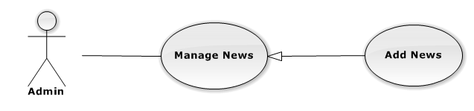

|  |  |  |  |  |
| --- | --- | --- | --- | --- |
| **USE CASE-UC056 SPECIFICATION** | | | | |
| **Use-case No.** | UC056 | **Use-case Version** | | 1.0 |
| **Use-case Name** | View News | | | |
| **Author** |  | | | |
| **Date** |  | **Priority** | High | |
| **Actor:**  **Summary:**  **Goal:**  **Triggers:**  **Preconditions:**  **Post Conditions:**  *On success:*  *On failure:*  **Main Success Scenario:**   |  |  |  | | --- | --- | --- | | **Step** | **User Action** | **System Response** | | 1. |  |  | | 2. |  |  |   **Alternative Scenario:**   |  |  |  |  | | --- | --- | --- | --- | | **No** | **Step** | **User Action** | **System Response** | | 1. | 1. |  |  | |  | 2. |  |  | | 2. | 1. |  |  | |  | 2. |  |  |   **Exceptions:**   |  |  |  | | --- | --- | --- | | **No** | **User Action** | **System Response** | | 1. |  |  | | 2. |  |  | | 3. |  |  | | 4. |  |  | | 5. |  |  |   **Relationships:**  “Manage prices” abstract use case  **Business Rules:**   |  |  | | --- | --- | | **No** | **Business Rule Description** | | 1. |  | | 2. |  | | 3. |  | | | | | |

##### **AdminManage News – Edit News**

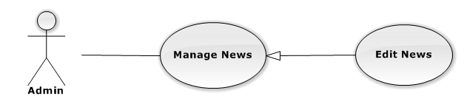

|  |  |  |  |  |
| --- | --- | --- | --- | --- |
| **USE CASE-UC057 SPECIFICATION** | | | | |
| **Use-case No.** | UC057 | **Use-case Version** | | 1.0 |
| **Use-case Name** | View News | | | |
| **Author** |  | | | |
| **Date** |  | **Priority** | High | |
| **Actor:**  **Summary:**  **Goal:**  **Triggers:**  **Preconditions:**  **Post Conditions:**  *On success:*  *On failure:*  **Main Success Scenario:**   |  |  |  | | --- | --- | --- | | **Step** | **User Action** | **System Response** | | 1. |  |  | | 2. |  |  |   **Alternative Scenario:**   |  |  |  |  | | --- | --- | --- | --- | | **No** | **Step** | **User Action** | **System Response** | | 1. | 1. |  |  | |  | 2. |  |  | | 2. | 1. |  |  | |  | 2. |  |  |   **Exceptions:**   |  |  |  | | --- | --- | --- | | **No** | **User Action** | **System Response** | | 1. |  |  | | 2. |  |  | | 3. |  |  | | 4. |  |  | | 5. |  |  |   **Relationships:**  “Manage prices” abstract use case  **Business Rules:**   |  |  | | --- | --- | | **No** | **Business Rule Description** | | 1. |  | | 2. |  | | 3. |  | | | | | |

##### **AdminManage News – Delete News**



|  |  |  |  |  |
| --- | --- | --- | --- | --- |
| **USE CASE-UC058 SPECIFICATION** | | | | |
| **Use-case No.** | UC058 | **Use-case Version** | | 1.0 |
| **Use-case Name** | View News | | | |
| **Author** |  | | | |
| **Date** |  | **Priority** | High | |
| **Actor:**  **Summary:**  **Goal:**  **Triggers:**  **Preconditions:**  **Post Conditions:**  *On success:*  *On failure:*  **Main Success Scenario:**   |  |  |  | | --- | --- | --- | | **Step** | **User Action** | **System Response** | | 1. |  |  | | 2. |  |  |   **Alternative Scenario:**   |  |  |  |  | | --- | --- | --- | --- | | **No** | **Step** | **User Action** | **System Response** | | 1. | 1. |  |  | |  | 2. |  |  | | 2. | 1. |  |  | |  | 2. |  |  |   **Exceptions:**   |  |  |  | | --- | --- | --- | | **No** | **User Action** | **System Response** | | 1. |  |  | | 2. |  |  | | 3. |  |  | | 4. |  |  | | 5. |  |  |   **Relationships:**  “Manage prices” abstract use case  **Business Rules:**   |  |  | | --- | --- | | **No** | **Business Rule Description** | | 1. |  | | 2. |  | | 3. |  | | | | | |

#### Admin Manage Users

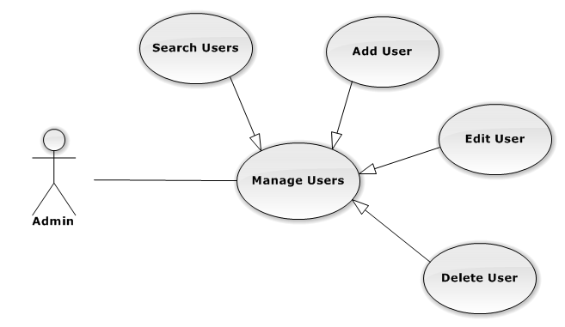

##### **AdminManage Users – Search Users**

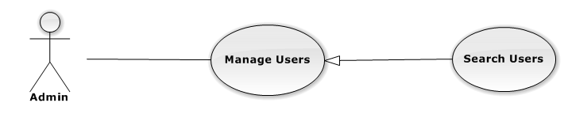

|  |  |  |  |  |
| --- | --- | --- | --- | --- |
| **USE CASE-UC059 SPECIFICATION** | | | | |
| **Use-case No.** | UC059 | **Use-case Version** | | 1.0 |
| **Use-case Name** | View News | | | |
| **Author** |  | | | |
| **Date** |  | **Priority** | High | |
| **Actor:**  **Summary:**  **Goal:**  **Triggers:**  **Preconditions:**  **Post Conditions:**  *On success:*  *On failure:*  **Main Success Scenario:**   |  |  |  | | --- | --- | --- | | **Step** | **User Action** | **System Response** | | 1. |  |  | | 2. |  |  |   **Alternative Scenario:**   |  |  |  |  | | --- | --- | --- | --- | | **No** | **Step** | **User Action** | **System Response** | | 1. | 1. |  |  | |  | 2. |  |  | | 2. | 1. |  |  | |  | 2. |  |  |   **Exceptions:**   |  |  |  | | --- | --- | --- | | **No** | **User Action** | **System Response** | | 1. |  |  | | 2. |  |  | | 3. |  |  | | 4. |  |  | | 5. |  |  |   **Relationships:**  “Manage prices” abstract use case  **Business Rules:**   |  |  | | --- | --- | | **No** | **Business Rule Description** | | 1. |  | | 2. |  | | 3. |  | | | | | |

##### **AdminManage Users – Add User**

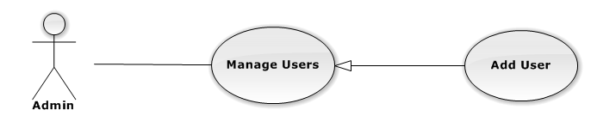

|  |  |  |  |  |
| --- | --- | --- | --- | --- |
| **USE CASE-UC060 SPECIFICATION** | | | | |
| **Use-case No.** | UC060 | **Use-case Version** | | 1.0 |
| **Use-case Name** | View News | | | |
| **Author** |  | | | |
| **Date** |  | **Priority** | High | |
| **Actor:**  **Summary:**  **Goal:**  **Triggers:**  **Preconditions:**  **Post Conditions:**  *On success:*  *On failure:*  **Main Success Scenario:**   |  |  |  | | --- | --- | --- | | **Step** | **User Action** | **System Response** | | 1. |  |  | | 2. |  |  |   **Alternative Scenario:**   |  |  |  |  | | --- | --- | --- | --- | | **No** | **Step** | **User Action** | **System Response** | | 1. | 1. |  |  | |  | 2. |  |  | | 2. | 1. |  |  | |  | 2. |  |  |   **Exceptions:**   |  |  |  | | --- | --- | --- | | **No** | **User Action** | **System Response** | | 1. |  |  | | 2. |  |  | | 3. |  |  | | 4. |  |  | | 5. |  |  |   **Relationships:**  “Manage prices” abstract use case  **Business Rules:**   |  |  | | --- | --- | | **No** | **Business Rule Description** | | 1. |  | | 2. |  | | 3. |  | | | | | |

##### **AdminManage Users – Edit User**

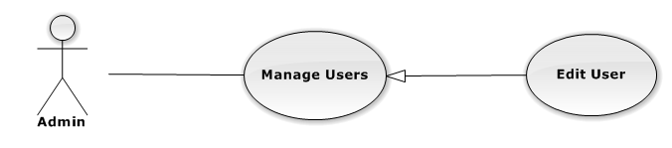

|  |  |  |  |  |
| --- | --- | --- | --- | --- |
| **USE CASE-UC061 SPECIFICATION** | | | | |
| **Use-case No.** | UC061 | **Use-case Version** | | 1.0 |
| **Use-case Name** | View News | | | |
| **Author** |  | | | |
| **Date** |  | **Priority** | High | |
| **Actor:**  **Summary:**  **Goal:**  **Triggers:**  **Preconditions:**  **Post Conditions:**  *On success:*  *On failure:*  **Main Success Scenario:**   |  |  |  | | --- | --- | --- | | **Step** | **User Action** | **System Response** | | 1. |  |  | | 2. |  |  |   **Alternative Scenario:**   |  |  |  |  | | --- | --- | --- | --- | | **No** | **Step** | **User Action** | **System Response** | | 1. | 1. |  |  | |  | 2. |  |  | | 2. | 1. |  |  | |  | 2. |  |  |   **Exceptions:**   |  |  |  | | --- | --- | --- | | **No** | **User Action** | **System Response** | | 1. |  |  | | 2. |  |  | | 3. |  |  | | 4. |  |  | | 5. |  |  |   **Relationships:**  “Manage prices” abstract use case  **Business Rules:**   |  |  | | --- | --- | | **No** | **Business Rule Description** | | 1. |  | | 2. |  | | 3. |  | | | | | |

##### **AdminManage Users – Delete User**

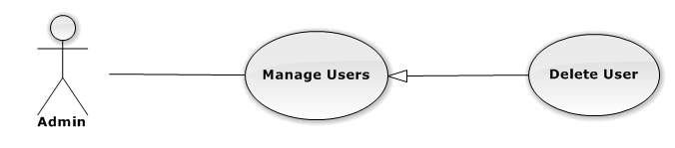

|  |  |  |  |  |
| --- | --- | --- | --- | --- |
| **USE CASE-UC062 SPECIFICATION** | | | | |
| **Use-case No.** | UC062 | **Use-case Version** | | 1.0 |
| **Use-case Name** | View News | | | |
| **Author** |  | | | |
| **Date** |  | **Priority** | High | |
| **Actor:**  **Summary:**  **Goal:**  **Triggers:**  **Preconditions:**  **Post Conditions:**  *On success:*  *On failure:*  **Main Success Scenario:**   |  |  |  | | --- | --- | --- | | **Step** | **User Action** | **System Response** | | 1. |  |  | | 2. |  |  |   **Alternative Scenario:**   |  |  |  |  | | --- | --- | --- | --- | | **No** | **Step** | **User Action** | **System Response** | | 1. | 1. |  |  | |  | 2. |  |  | | 2. | 1. |  |  | |  | 2. |  |  |   **Exceptions:**   |  |  |  | | --- | --- | --- | | **No** | **User Action** | **System Response** | | 1. |  |  | | 2. |  |  | | 3. |  |  | | 4. |  |  | | 5. |  |  |   **Relationships:**  “Manage prices” abstract use case  **Business Rules:**   |  |  | | --- | --- | | **No** | **Business Rule Description** | | 1. |  | | 2. |  | | 3. |  | | | | | |

#### AdminView System Statistics

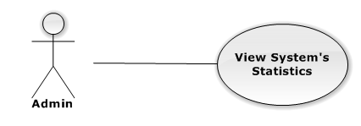

|  |  |  |  |  |
| --- | --- | --- | --- | --- |
| **USE CASE-UC063 SPECIFICATION** | | | | |
| **Use-case No.** | UC063 | **Use-case Version** | | 1.0 |
| **Use-case Name** | View News | | | |
| **Author** |  | | | |
| **Date** |  | **Priority** | High | |
| **Actor:**  **Summary:**  **Goal:**  **Triggers:**  **Preconditions:**  **Post Conditions:**  *On success:*  *On failure:*  **Main Success Scenario:**   |  |  |  | | --- | --- | --- | | **Step** | **User Action** | **System Response** | | 1. |  |  | | 2. |  |  |   **Alternative Scenario:**   |  |  |  |  | | --- | --- | --- | --- | | **No** | **Step** | **User Action** | **System Response** | | 1. | 1. |  |  | |  | 2. |  |  | | 2. | 1. |  |  | |  | 2. |  |  |   **Exceptions:**   |  |  |  | | --- | --- | --- | | **No** | **User Action** | **System Response** | | 1. |  |  | | 2. |  |  | | 3. |  |  | | 4. |  |  | | 5. |  |  |   **Relationships:**  “Manage prices” abstract use case  **Business Rules:**   |  |  | | --- | --- | | **No** | **Business Rule Description** | | 1. |  | | 2. |  | | 3. |  | | | | | |

### Non-functional Requirements

#### Reliability

#### Availability

#### Security

#### Maintainability

#### Portability

#### Performance

## Entity Relationship Diagram or Data Structure

### Entity Relationship Diagram

### Entity Detail